**LDAP**

By:

Keerthana A

Light Weight Directory Access protocol  
===================================  
  
  
4 Layers for Ldap  
=============  
  
1. your company  
2. Branch  
3. department  
4. users  
  
LDAP Directory / Database  
=========================  
Name : hpeco  
Branch 1: bangalore  
Branch2: Chennai

dn – distinguished name

dc – domain component

cn – common name

Installing OpenLdap Server  
-----------------------------------

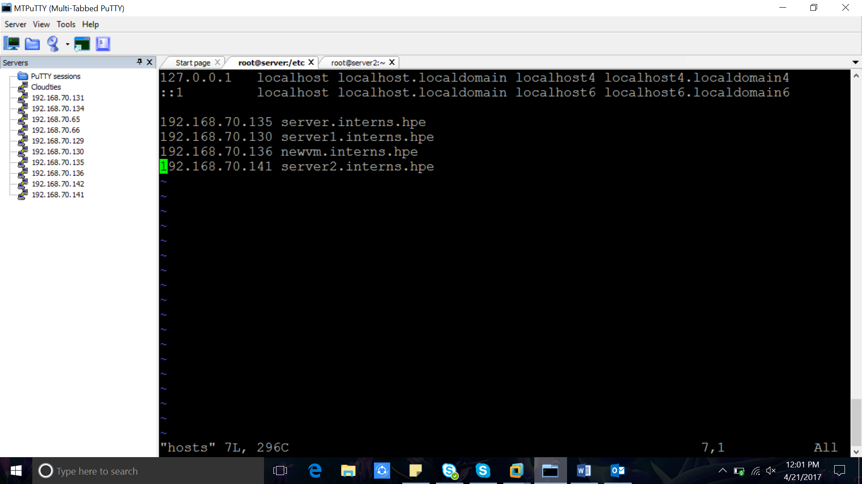  
  
1. Installing the packages  
  
yum install -y "openldap" migrationtools openldap-clients

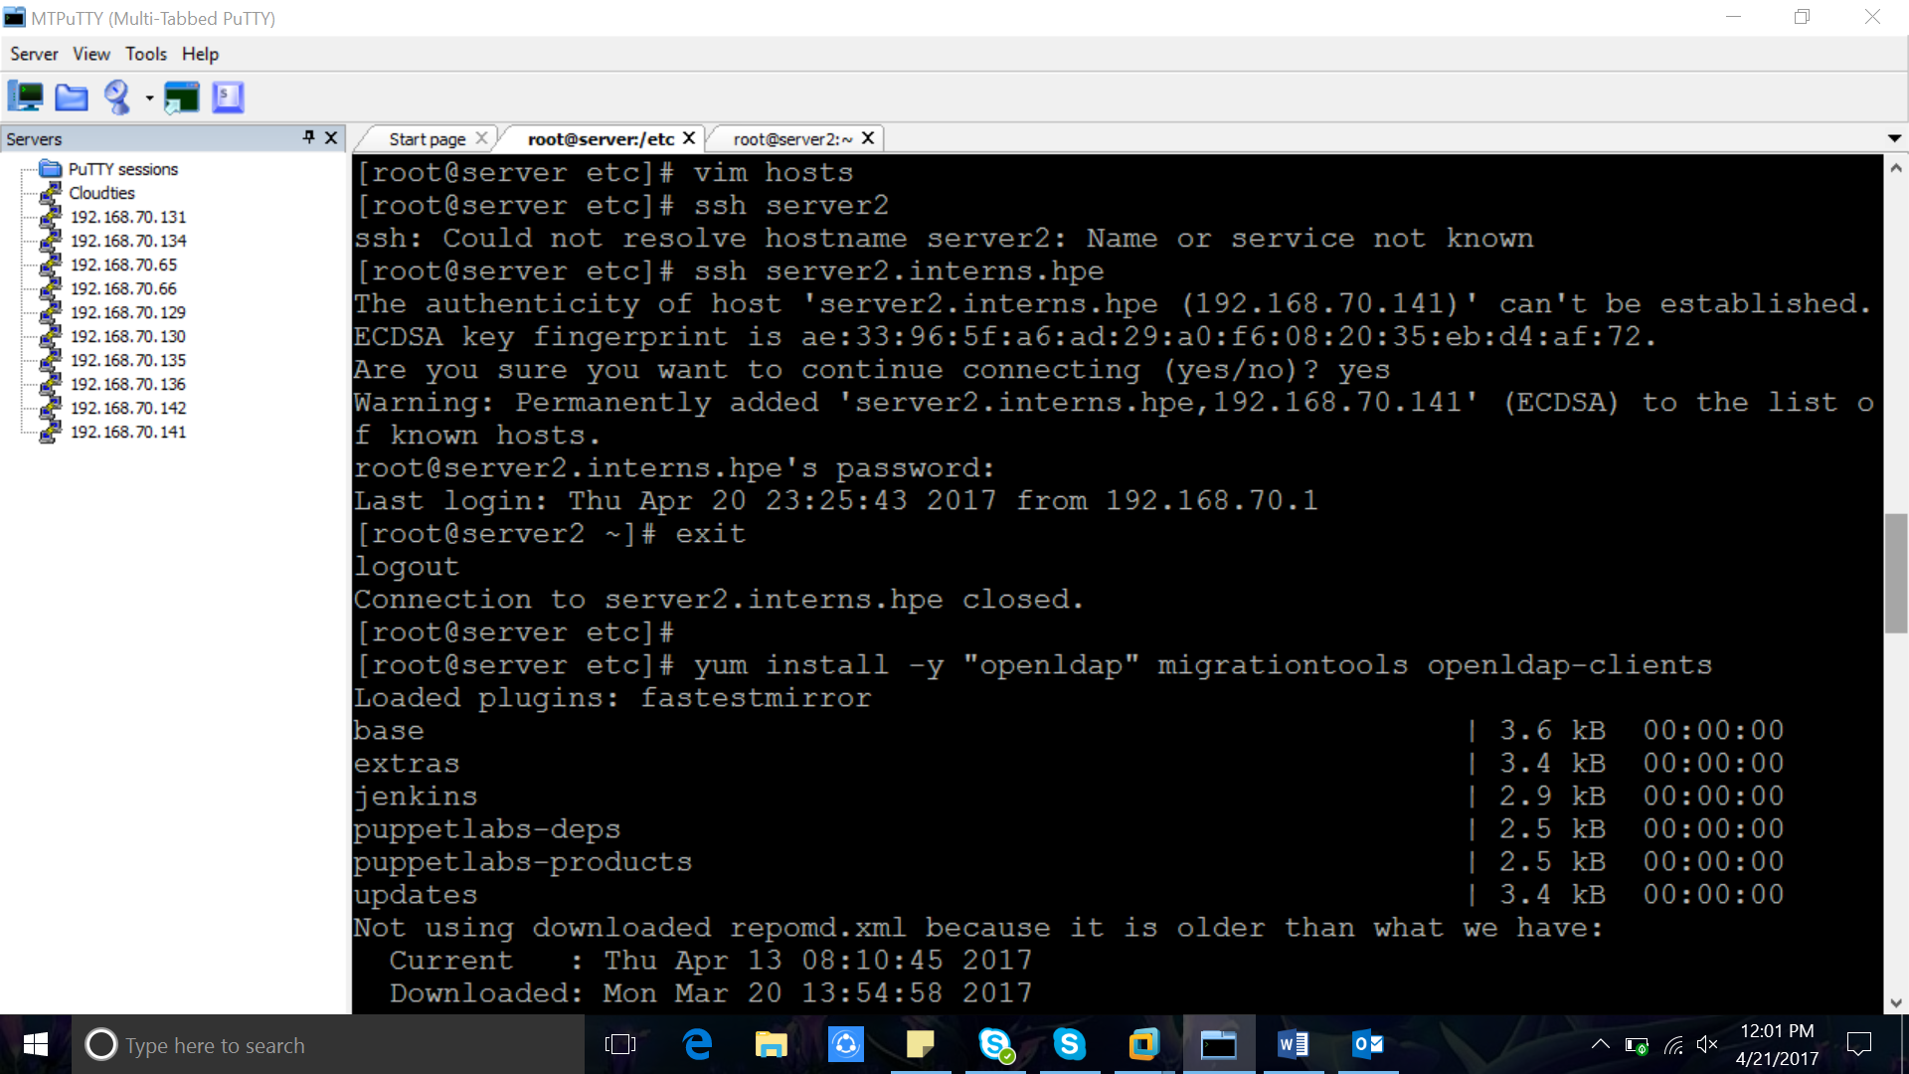  
  
migration tools - copying user details to ldap database(migrating data to ldap database)  
  
2. Create LDAP Password  
  
[root@host4 ~]# slappasswd  
New password:   
Re-enter new password:   
{SSHA}FQJy2/e830TwTngdcpYwcD9CJ+TM+KFN  
  
{SSHA}FQJy2/e830TwTngdcpYwcD9CJ+TM+KFN

Password: Admin@123

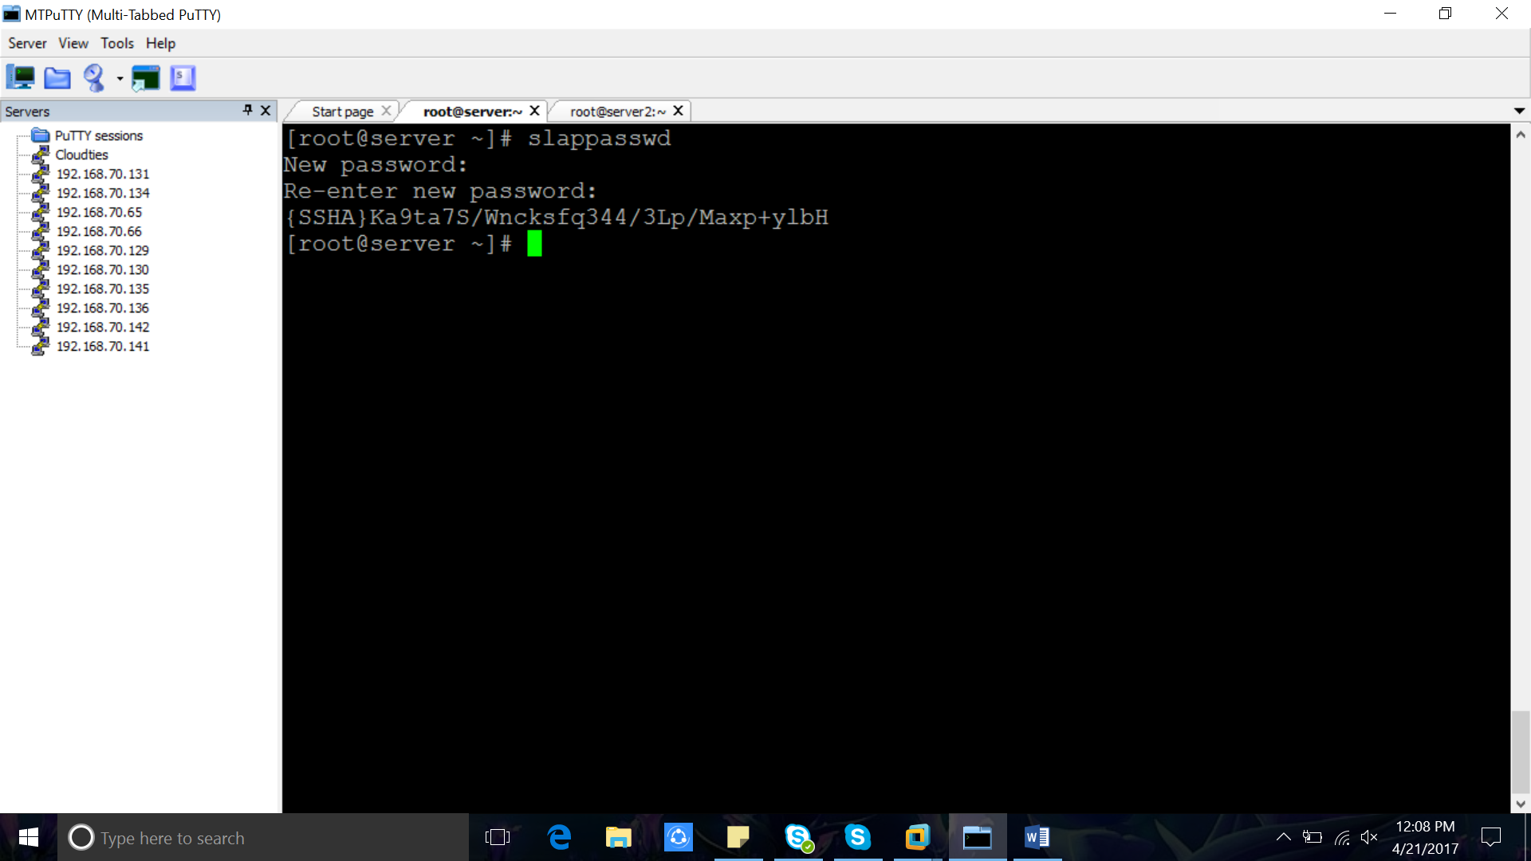  
3. LDAP configuration Directory  
  
/etc/openldap/slapd.d/cn=config

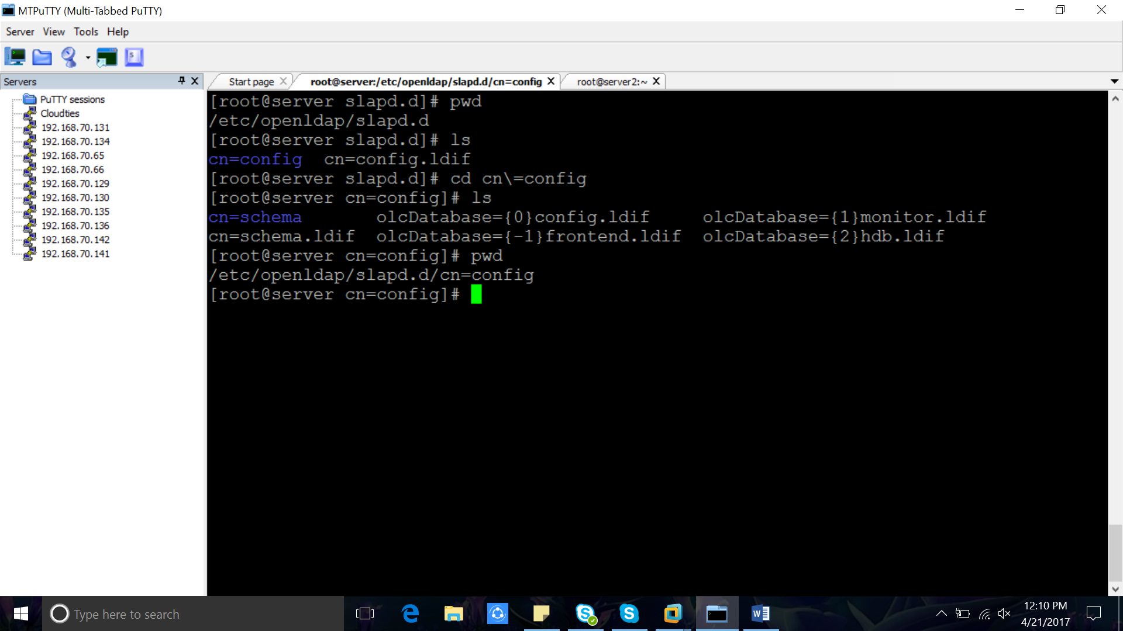  
  
Change these configuration files  
-------------------------------------------  
  
3.1. vim olcDatabase\=\{2\}hdb.ldif

==============================================  
olcSuffix: dc=host4,dc=cloudties,dc=in  
olcRootDN: cn=Manager,dc=host4,dc=cloudties,dc=in  
olcRootPW: {SSHA}Ka9ta7S/Wncksfq344/3Lp/Maxp+ylbH  
==============================================  
  
3.2. vim olcDatabase\=\{1\}monitor.ldif   
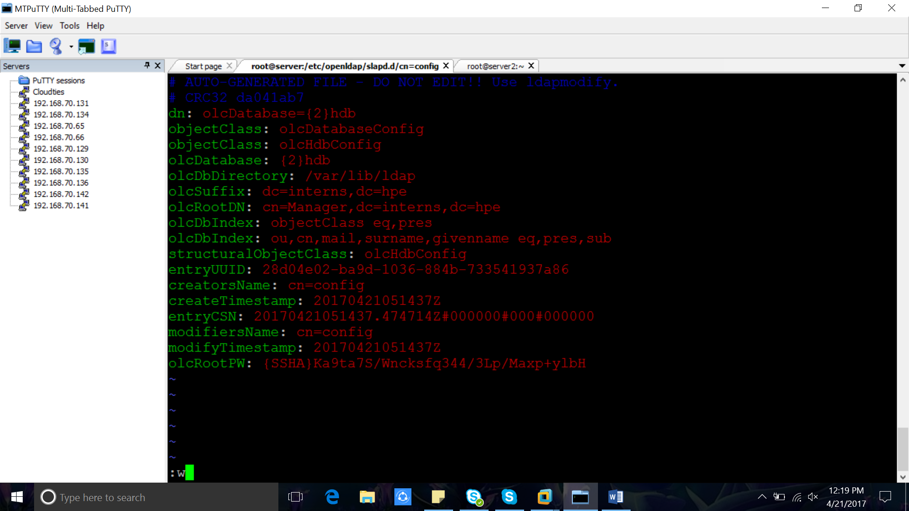  
========================================

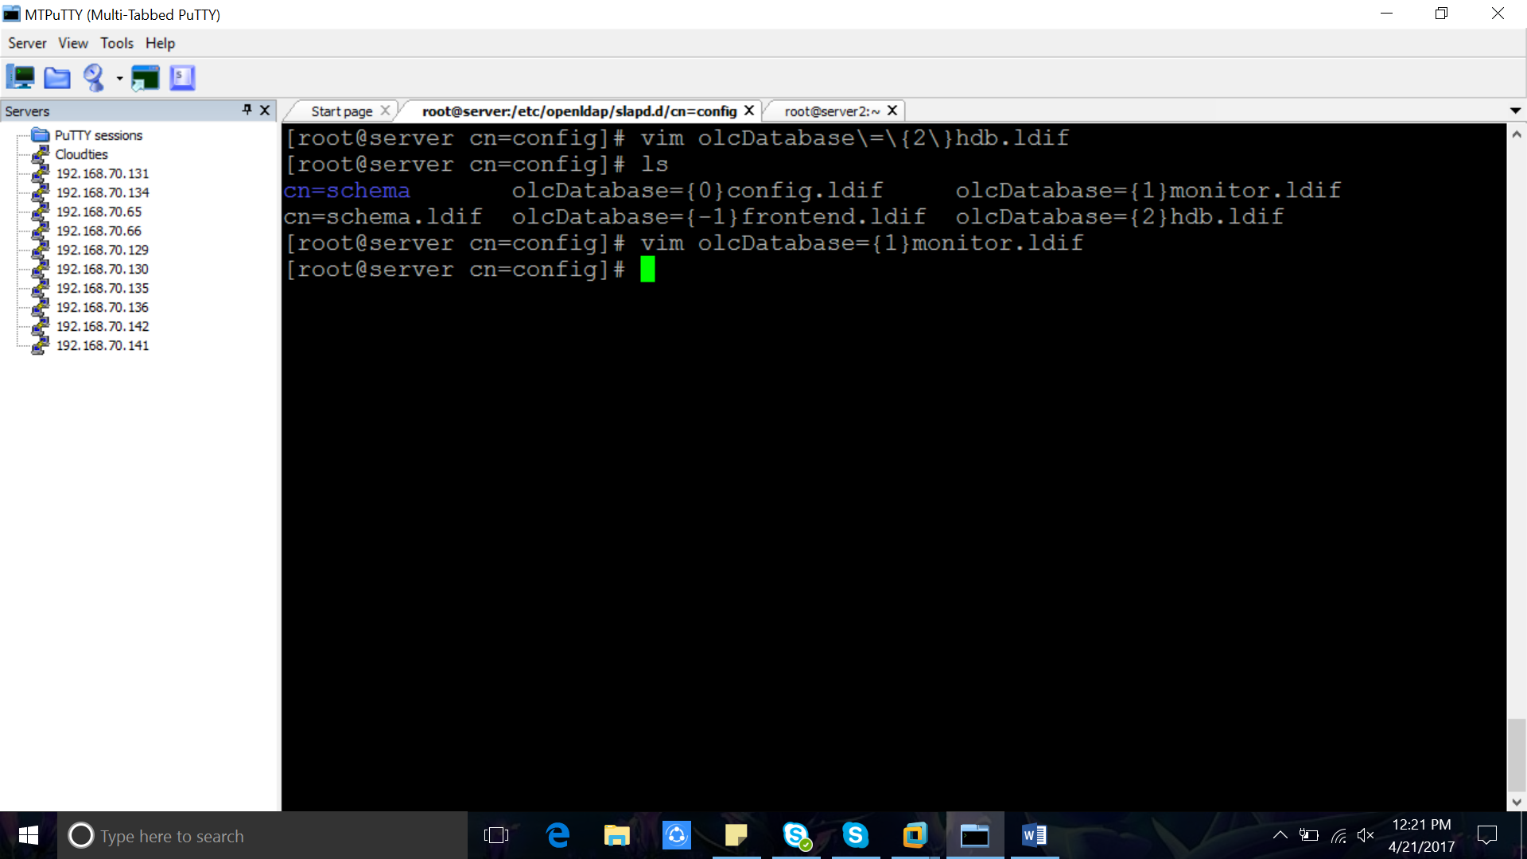 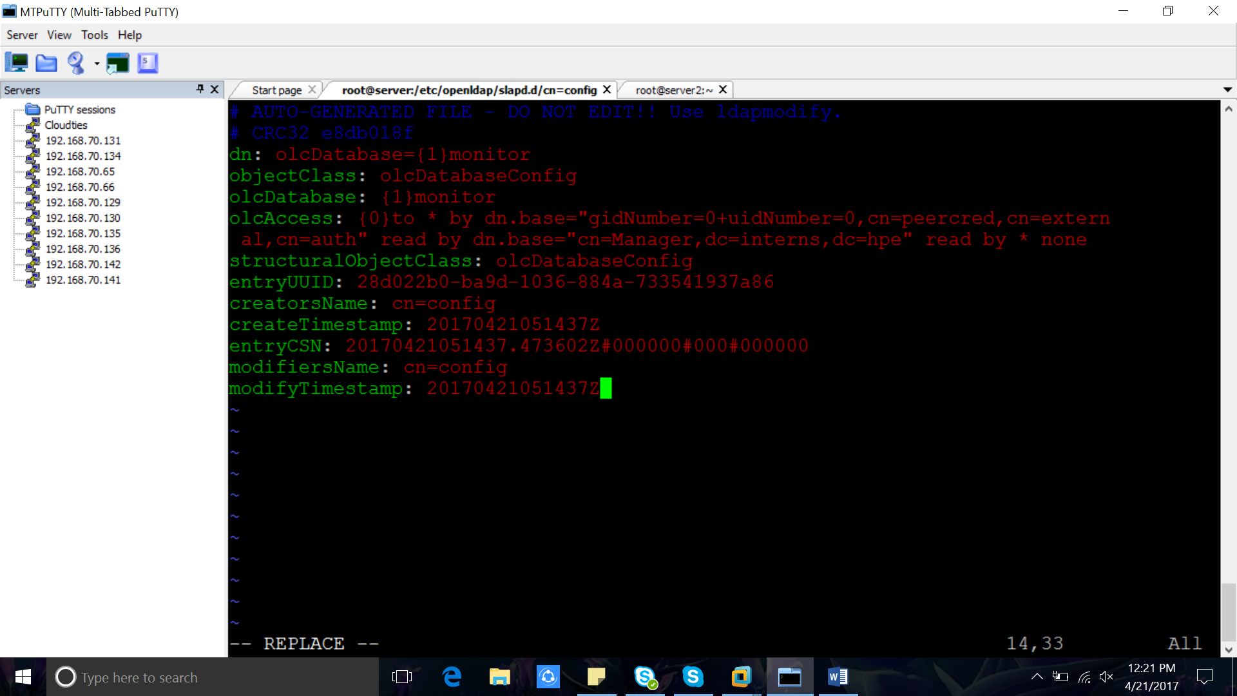   
olcAccess: {0}to * by dn.base="gidNumber=0+uidNumber=0,cn=peercred,cn=extern  
al,cn=auth" read by dn.base="cn=Manager,dc=host4,dc=cloudties,dc=in" read by * none  
========================================  
  
4. Test the configuration   
  
[root@host4 cn=config]# slaptest -u  
58f6fe90 ldif_read_file: checksum error on "/etc/openldap/slapd.d/cn=config/olcDatabase={1}monitor.ldif"  
58f6fe90 ldif_read_file: checksum error on "/etc/openldap/slapd.d/cn=config/olcDatabase={2}hdb.ldif"  
config file testing succeeded  
  
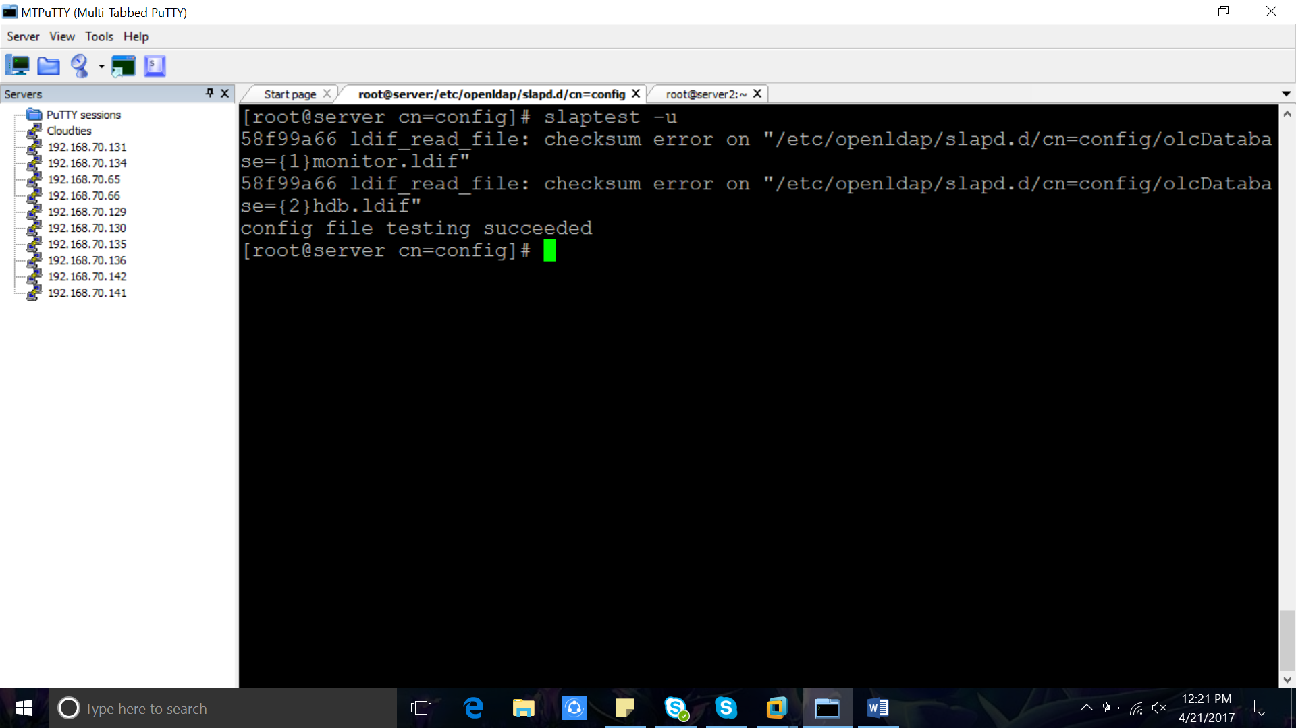  
ignore the checksum errors   
  
5. start and enable LDAP service (slapd)  
  
=====================================  
[root@host4 cn=config]# systemctl start slapd  
[root@host4 cn=config]# systemctl enable slapd  
Created symlink from /etc/systemd/system/multi-user.target.wants/slapd.service to /usr/lib/systemd/system/slapd.service.  
[root@host4 cn=config]#   
=======================================  
  
6. Creating Database for LDAP  
  
6.1.copy the sample database example of ldap from /usr/share to /var/lib/ldap directory  
  
cp -rf /usr/share/openldap-servers/DB_CONFIG.example /var/lib/ldap/DB_CONFIG  
  
6.2 Add LDAP schemas  
  
========================================

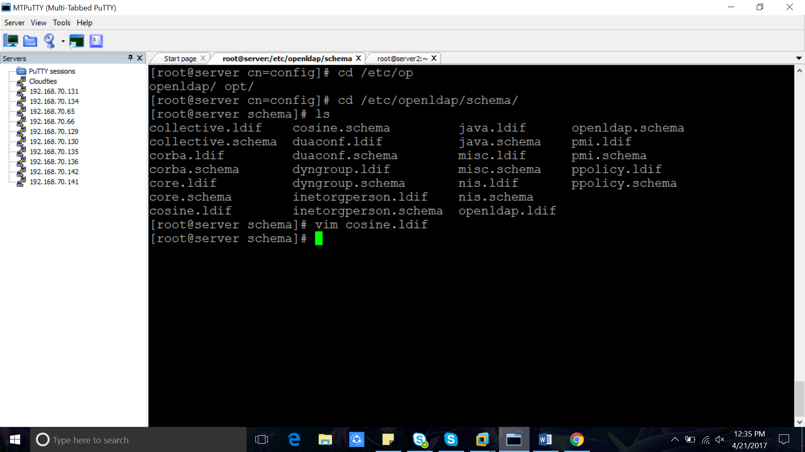  
[root@host4 cn=config]# ldapadd -Y EXTERNAL -H ldapi:// -f /etc/openldap/schema/cosine.ldif  
  
SASL/EXTERNAL authentication started  
SASL username: gidNumber=0+uidNumber=0,cn=peercred,cn=external,cn=auth  
SASL SSF: 0  
adding new entry "cn=cosine,cn=schema,cn=config"  
======================================================  
======================================================  
[root@host4 cn=config]# ldapadd -Y EXTERNAL -H ldapi:// -f /etc/openldap/schema/nis.ldif   
  
SASL/EXTERNAL authentication started  
SASL username: gidNumber=0+uidNumber=0,cn=peercred,cn=external,cn=auth  
SASL SSF: 0  
adding new entry "cn=nis,cn=schema,cn=config"  
========================================================  
  
========================================================  
[root@host4 cn=config]# ldapadd -Y EXTERNAL -H ldapi:// -f /etc/openldap/schema/inetorgperson.ldif   
  
SASL/EXTERNAL authentication started  
SASL username: gidNumber=0+uidNumber=0,cn=peercred,cn=external,cn=auth  
SASL SSF: 0  
adding new entry "cn=inetorgperson,cn=schema,cn=config"  
=========================================================

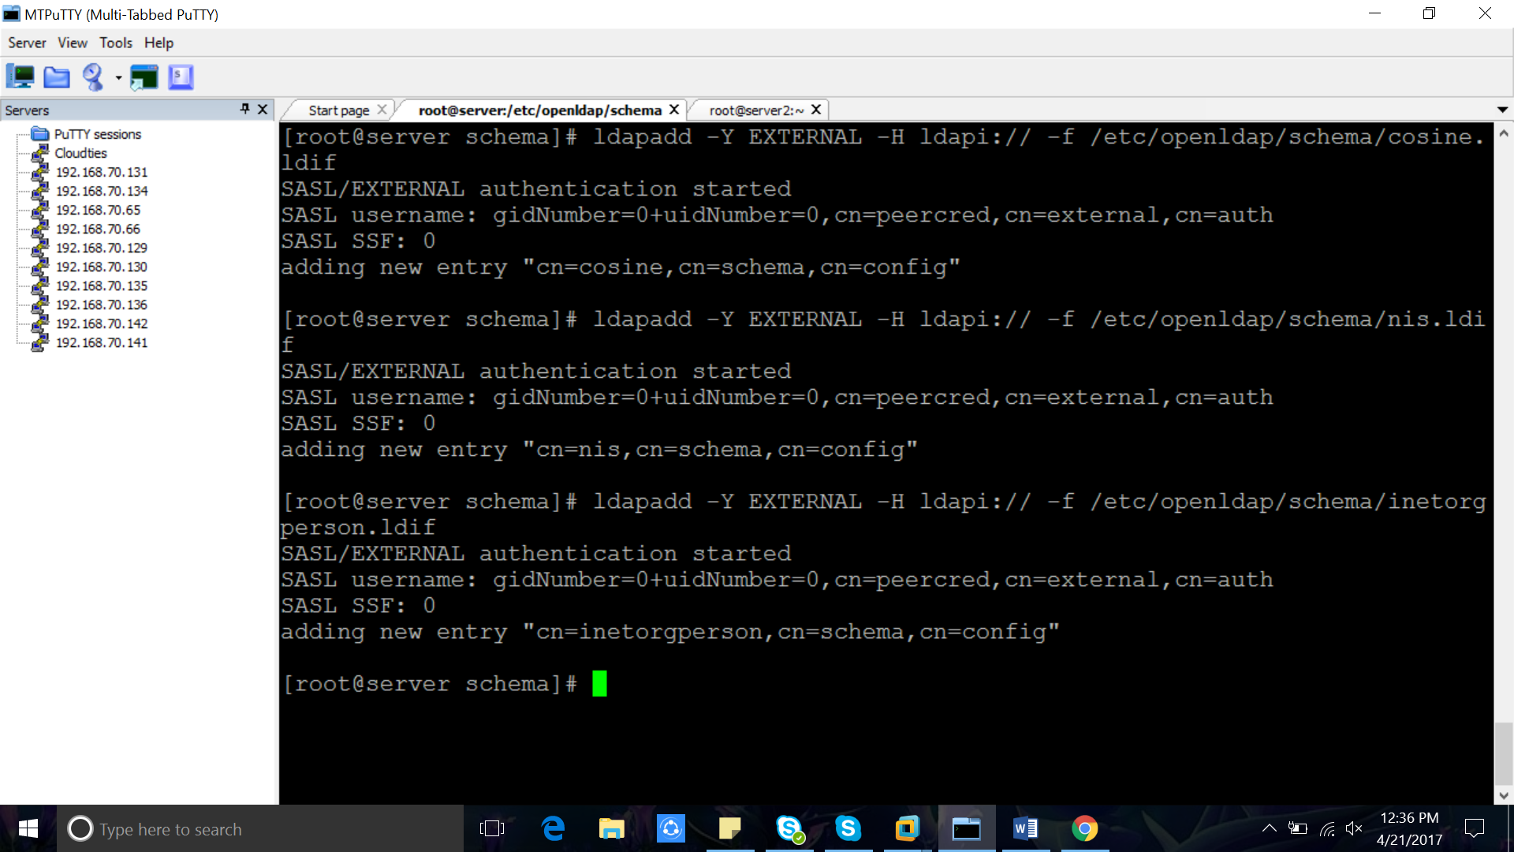  
  
7. Create Self-Signed Certificates  
  
7.2 openssl req -new -x509 -nodes -out /etc/pki/tls/certs/cloudties.pem -keyout /etc/pki/tls/certs/cloudtieskey.pem -days 365  
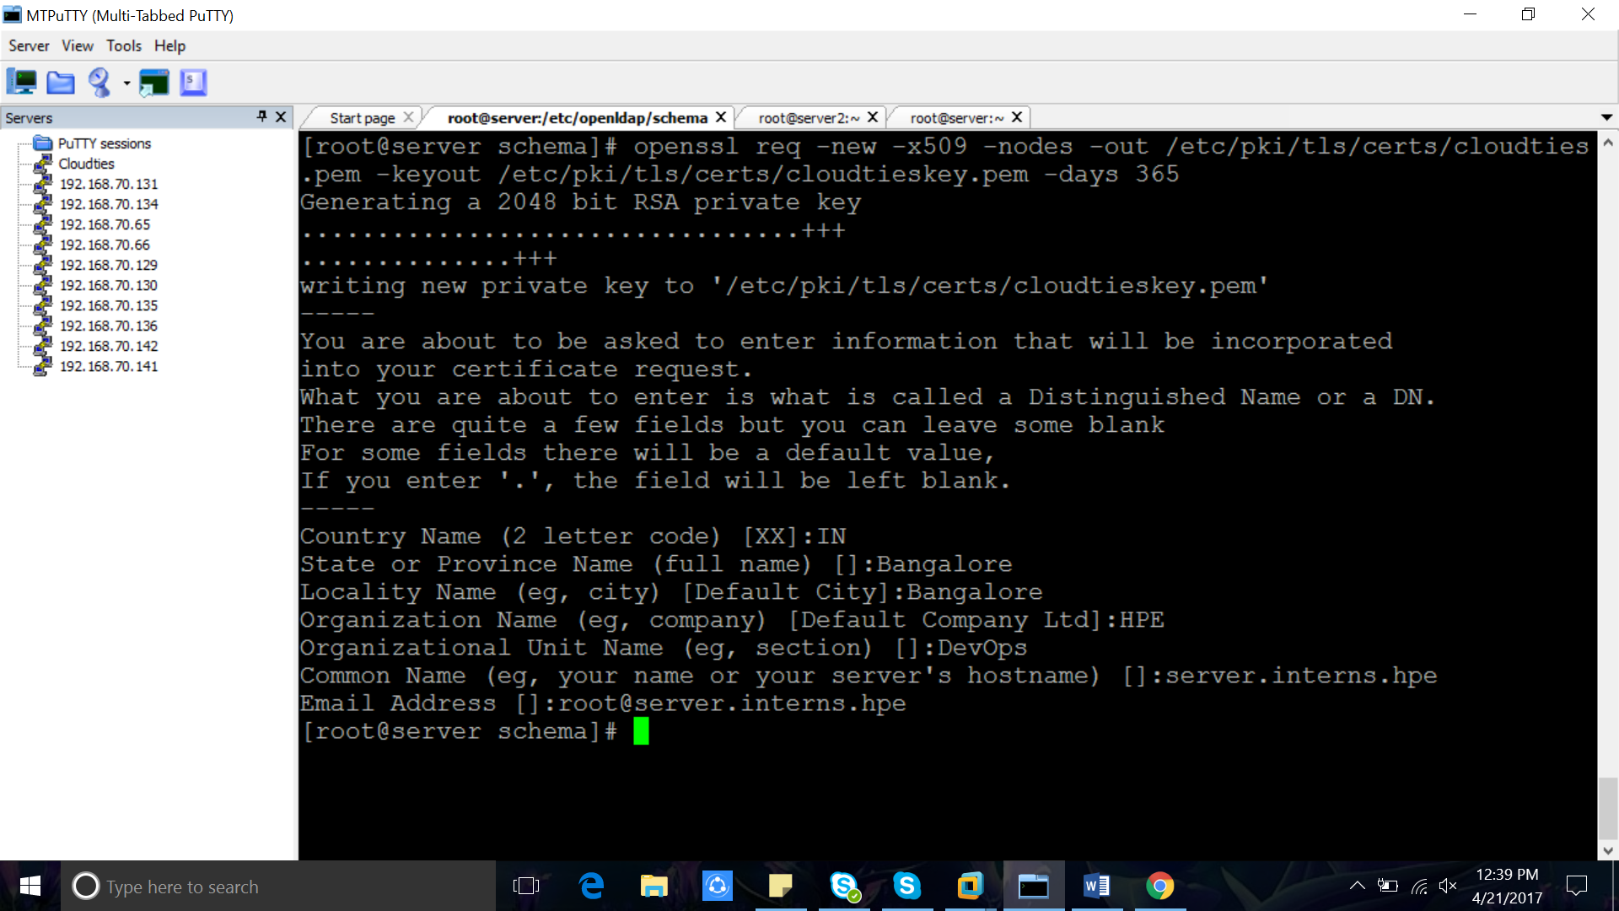  
==============================================  
country Name (2 letter code) [XX]:IN  
State or Province Name (full name) []:Bangalore  
Locality Name (eg, city) [Default City]:Bangalore  
Organization Name (eg, company) [Default Company Ltd]:Cloudties  
Organizational Unit Name (eg, section) []:DevOps  
Common Name (eg, your name or your server's hostname) []:host4.cloudties.in  
Email Address []:root@host4.cloudties.in  
===============================================  
  
Verify Certificates Created or Not  
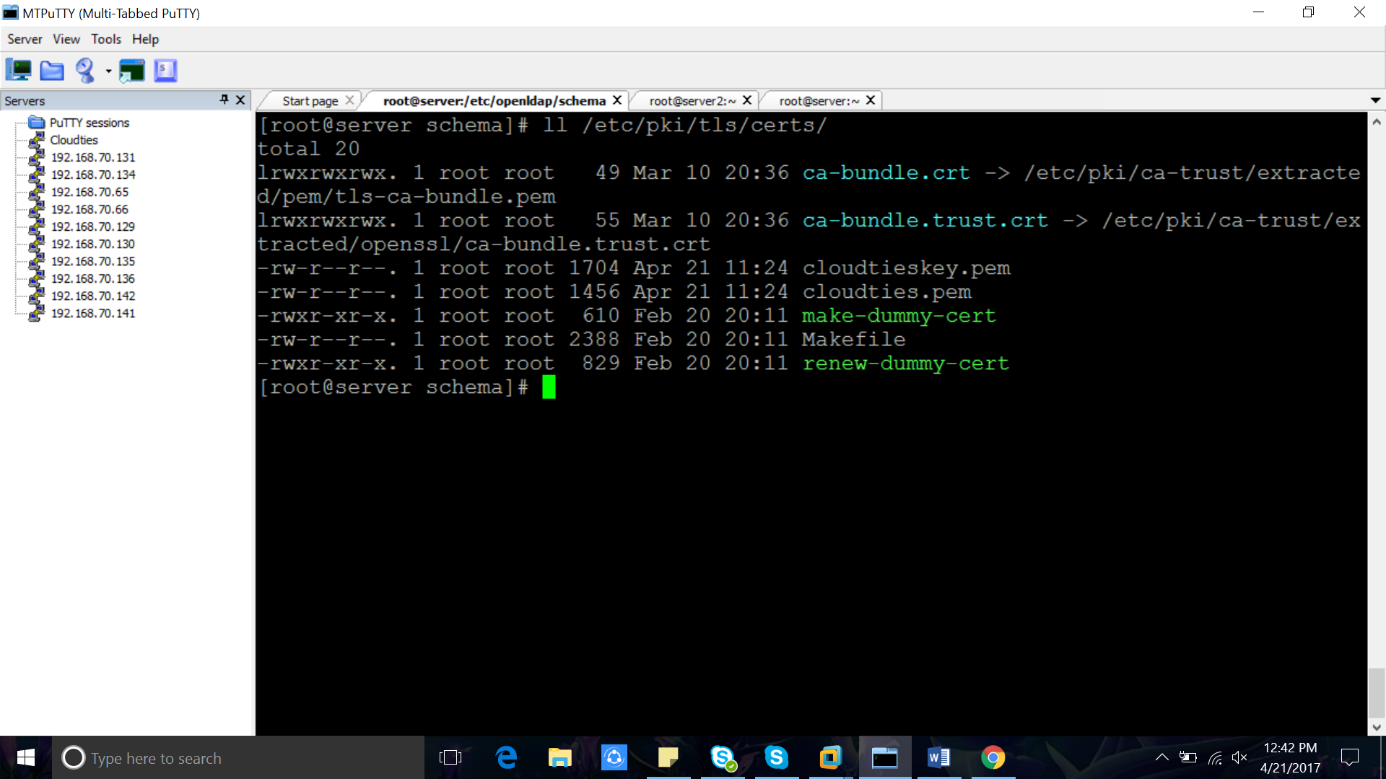  
================================================  
[root@host4 cn=config]# ll /etc/pki/tls/certs/  
total 20  
lrwxrwxrwx. 1 root root 49 Mar 24 20:57 ca-bundle.crt -> /etc/pki/ca-trust/extracted/pem/tls-ca-bundle.pem  
lrwxrwxrwx. 1 root root 55 Mar 24 20:57 ca-bundle.trust.crt -> /etc/pki/ca-trust/extracted/openssl/ca-bundle.trust.crt  
-rw-r--r--. 1 root root 1704 Apr 19 05:02 cloudtieskey.pem  
-rw-r--r--. 1 root root 1472 Apr 19 05:02 cloudties.pem  
==================================================  
  
  
7.2 add certificate details to LDAP Configuration File   
  
vim /etc/openldap/slapd.d/cn=config/olcDatabase\=\{2\}hdb.ldif  
  
======================================================  
  
olcTLSCertifcateFile: /etc/pki/tls/certs/cloudties.pem  
olcTLSCertificateKeyFile: /etc/pki/tls/certs/cloudtieskey.pem   
=======================================================  
  
8. Create BaseObjects  
  
for base objects we need migration tools(already installed )  
  
under /usr/share/migrationtools we can see some files related to migration  
  
=======================================================  
[root@host4 cn=config]# ll /usr/share/migrationtools/  
total 128  
-rwxr-xr-x. 1 root root 2652 Jun 9 2014 migrate_aliases.pl  
-rwxr-xr-x. 1 root root 2950 Jun 9 2014 migrate_all_netinfo_offline.sh  
-rwxr-xr-x. 1 root root 2946 Jun 9 2014 migrate_all_netinfo_online.sh  
-rwxr-xr-x. 1 root root 3011 Jun 9 2014 migrate_all_nis_offline.sh  
-rwxr-xr-x. 1 root root 3006 Jun 9 2014 migrate_all_nis_online.sh  
-rwxr-xr-x. 1 root root 3164 Jun 9 2014 migrate_all_nisplus_offline.sh  
-rwxr-xr-x. 1 root root 3146 Jun 9 2014 migrate_all_nisplus_online.sh  
-rwxr-xr-x. 1 root root 5267 Jun 9 2014 migrate_all_offline.sh  
-rwxr-xr-x. 1 root root 7468 Jun 9 2014 migrate_all_online.sh  
-rwxr-xr-x. 1 root root 3278 Jun 9 2014 migrate_automount.pl  
-rwxr-xr-x. 1 root root 2608 Jun 9 2014 migrate_base.pl  
-rw-r--r--. 1 root root 8880 Jun 9 2014 migrate_common.ph  
-rwxr-xr-x. 1 root root 2952 Jun 9 2014 migrate_fstab.pl  
=============================================================  
  
This migration files will help in moving local users as LDAP users  
  
8.1   
==========================================  
cd /usr/share/migrationtools/  
  
vim migrate_common.ph  
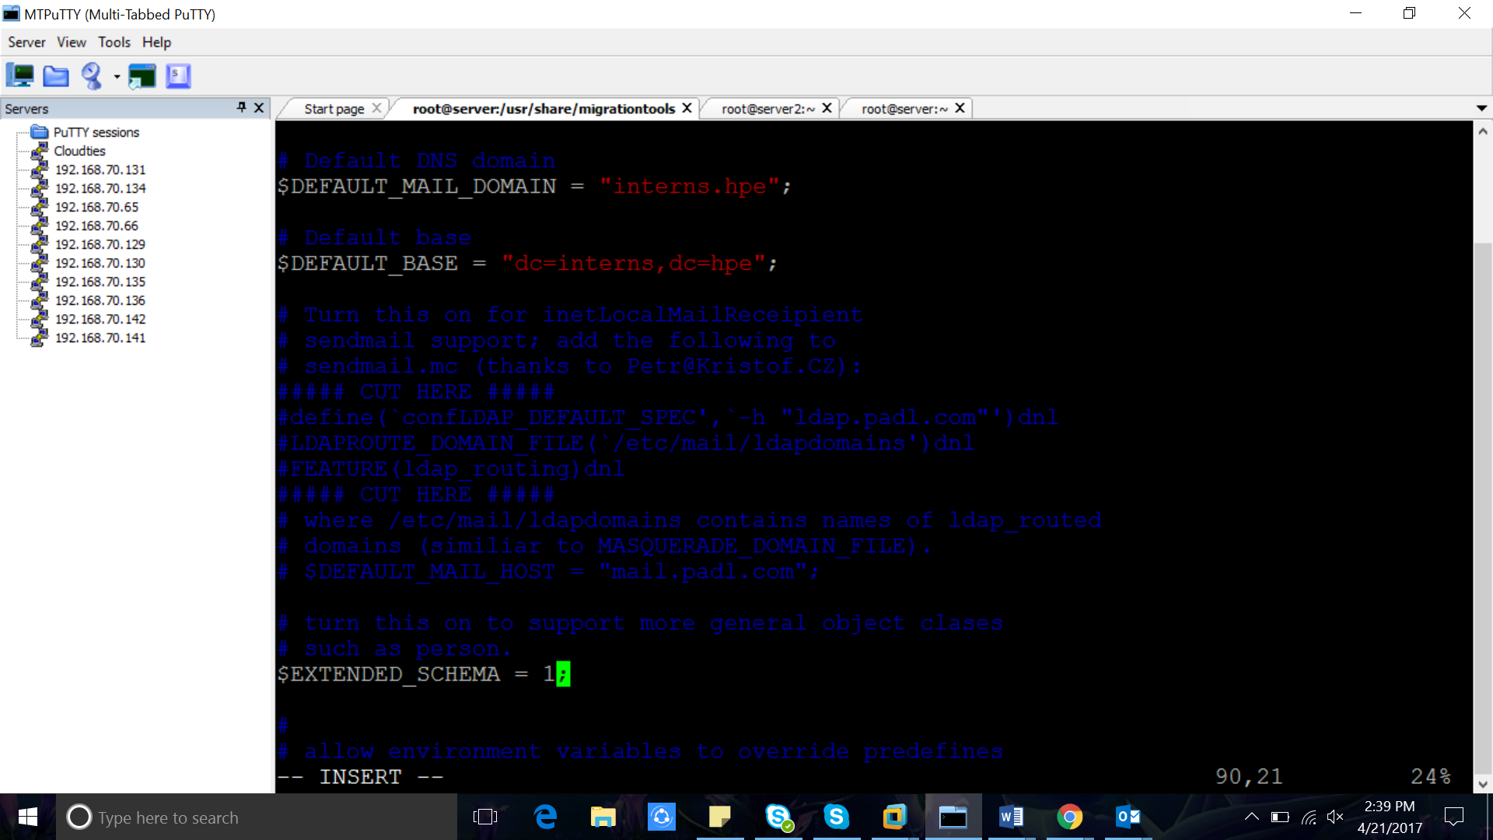  
line No : 71   
change it in to   
------------------------------------------  
# Default DNS domain  
71 $DEFAULT_MAIL_DOMAIN = "cloudties.in";  
72   
73 # Default base   
74 $DEFAULT_BASE = "dc=cloudties,dc=in";  
-------------------------------------------  
  
and in Line No : 90   
  
change extended_schema from 0 to 1  
  
$EXTENDED_SCHEMA = 1;  
  
sava and exit  
  
9. Create Baseldif file  
  
create a file in /root/base.ldif  
  
[root@host4 migrationtools]# vim /root/base.ldif  
  
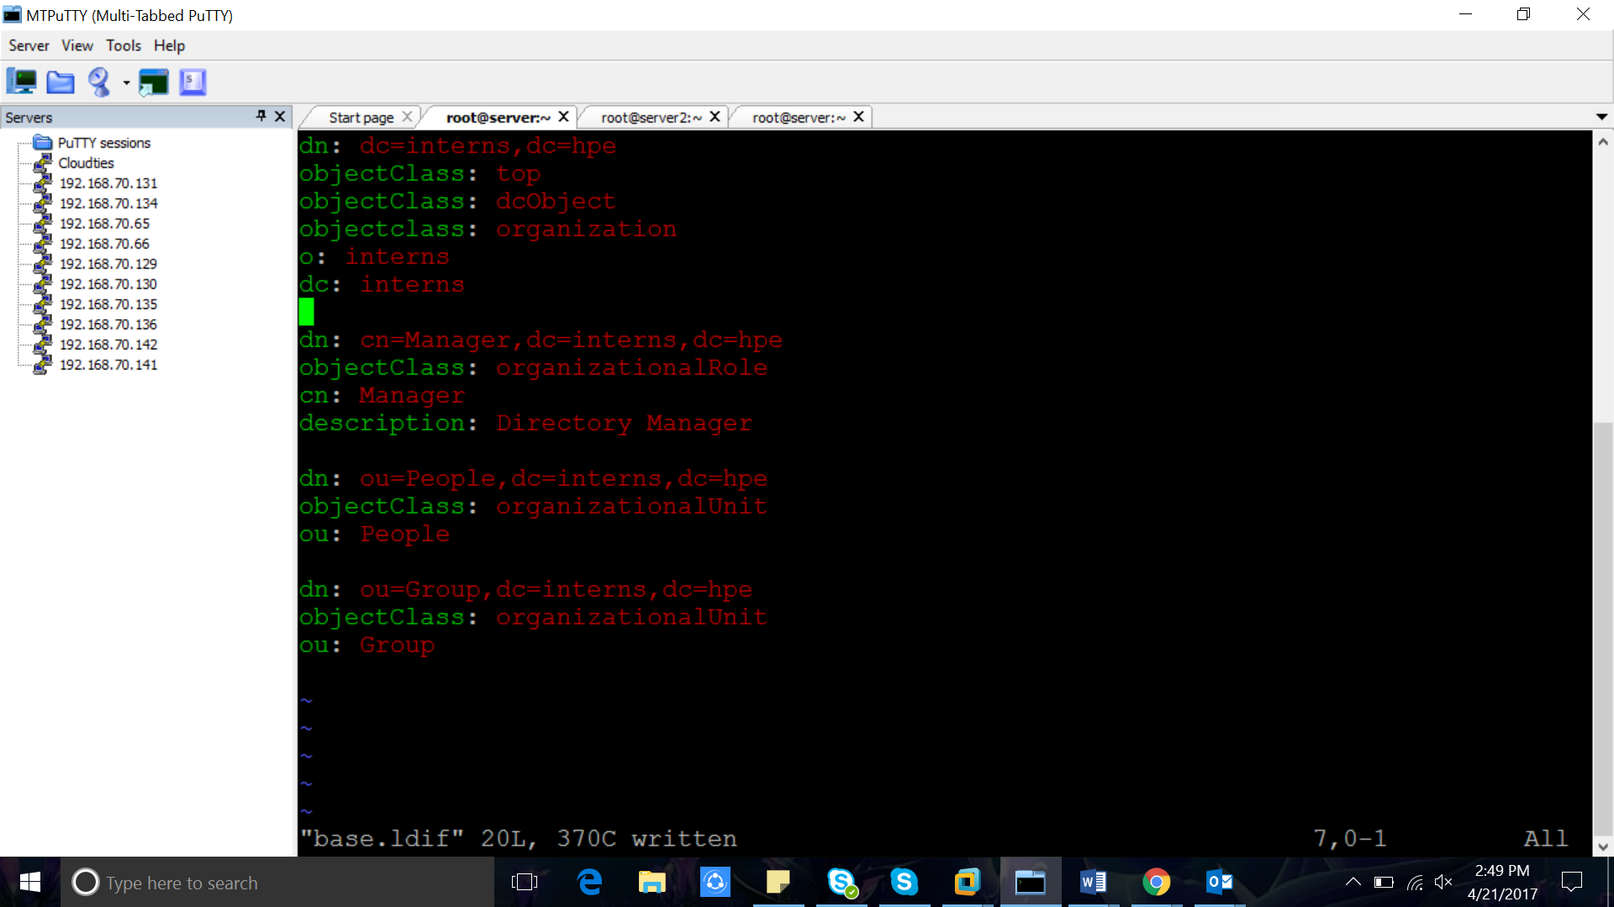  
===========================================================  
dn: dc=cloudties,dc=in  
objectClass: top  
objectClass: dcObject  
objectclass: organization  
o: cloudties in  
dc: cloudties  
  
dn: cn=Manager,dc=cloudties,dc=in  
objectClass: organizationalRole  
cn: Manager  
description: Directory Manager  
  
dn: ou=People,dc=cloudties,dc=in  
objectClass: organizationalUnit  
ou: People  
  
dn: ou=Group,dc=cloudties,dc=in  
objectClass: organizationalUnit  
ou: Group  
===============================================================  
  
10. Create Local users  
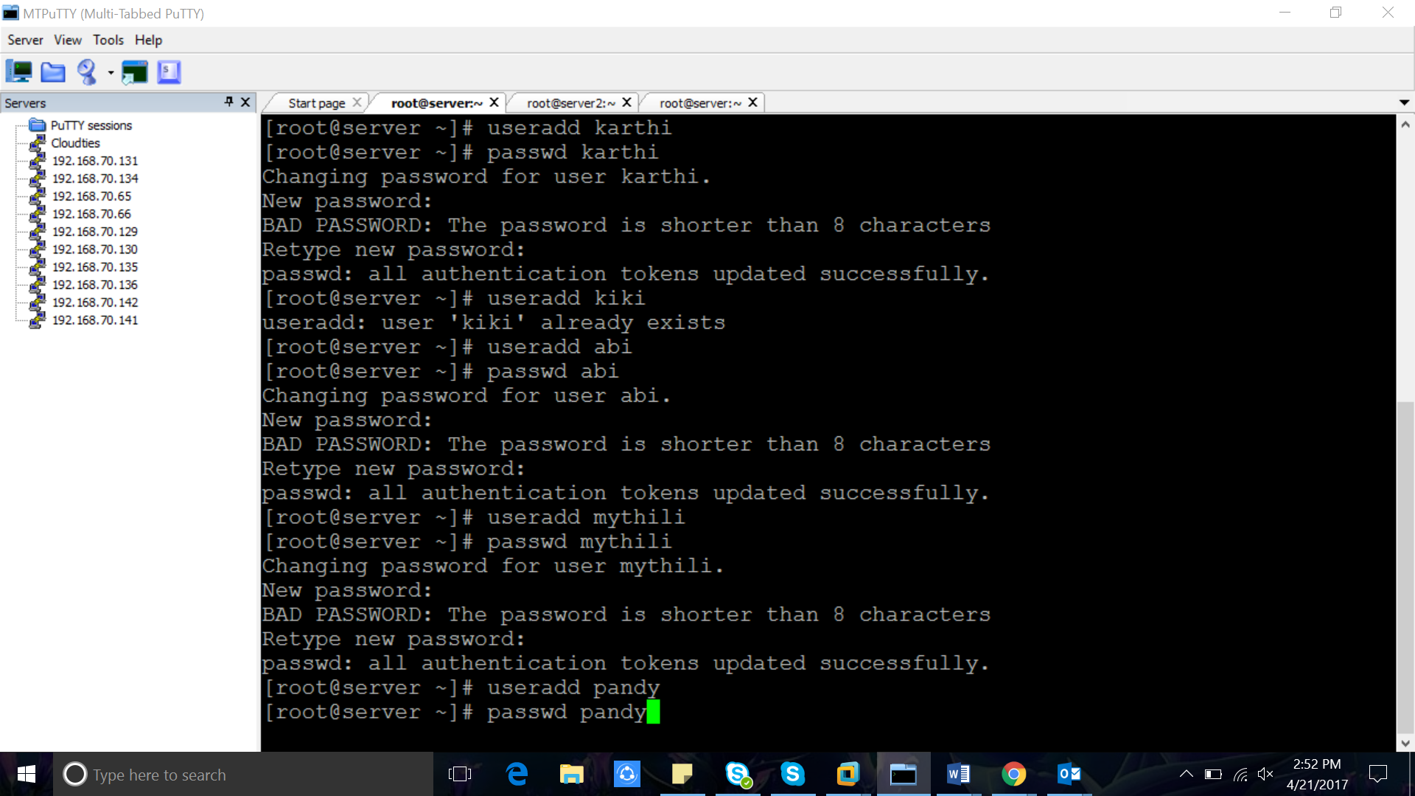

Password: admin   
useradd shafeeque  
passwd shafeeque  
  
useradd shifin  
passwd shifin  
  
10.1 Filterout users from /etc/passwd (from service users)  
  
We only need valid linux users  
  
grep ":10[0-9][0-9]" /etc/passwd > /root/passwd  
  
  
10.2 Convert individual files to LDAP format (ldif)  
  
We can use the migration tools to convert  
  
==========================================  
[root@host4 migrationtools]# pwd  
/usr/share/migrationtools  
[root@host4 migrationtools]# ./migrate_passwd.pl /root/passwd /root/users.ldif  
  
[root@host4 migrationtools]# ./migrate_group.pl /root/group /root/groups.ldif  
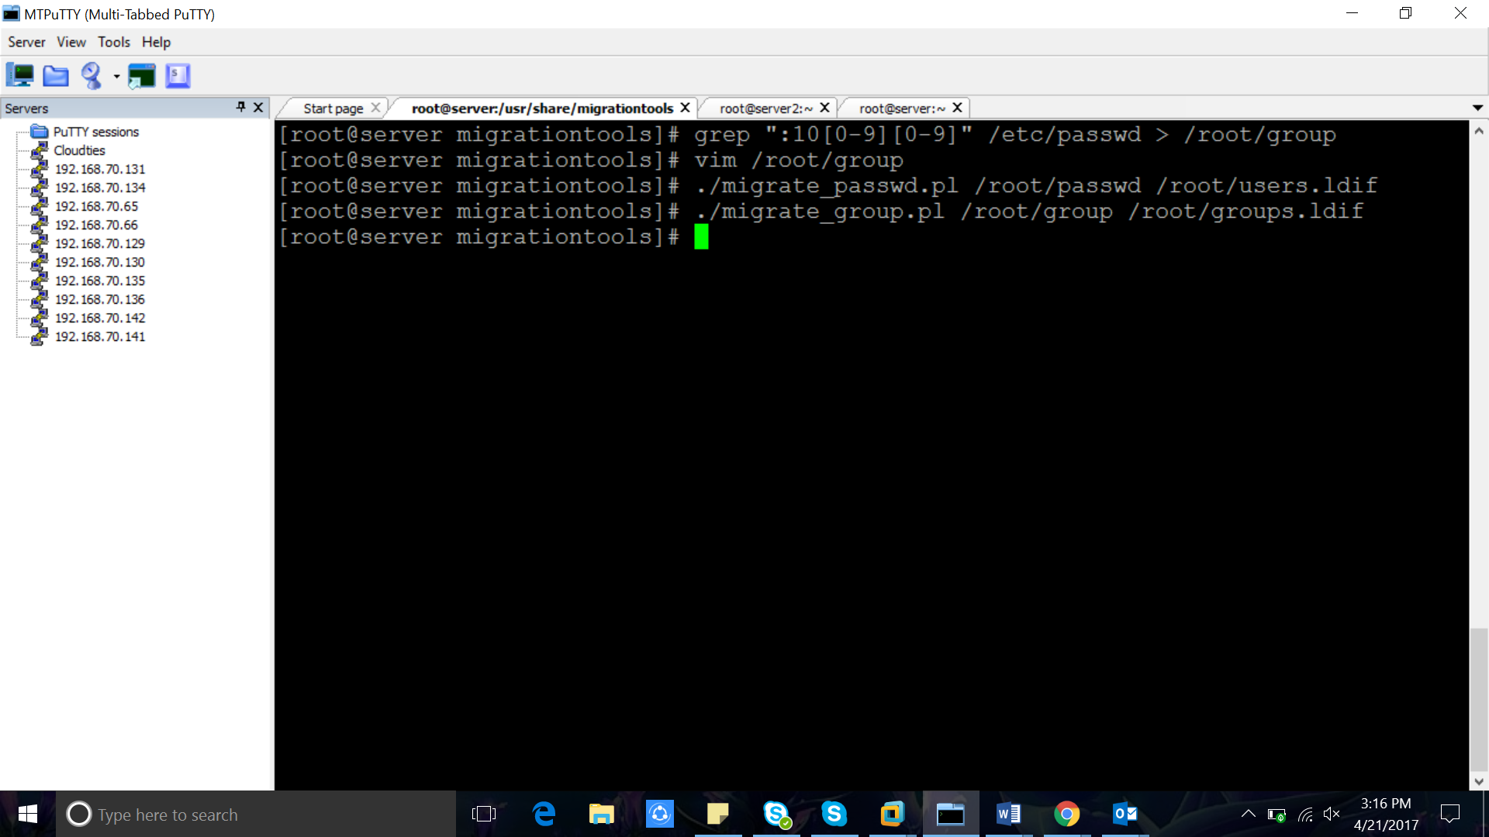  
===========================================  
  
11. Importing these ldif files in to LDAP database   
  
so far 3 ldif files   
  
1. /root/base.ldif  
2. /root/users.ldif  
3. /root/group.ldif  
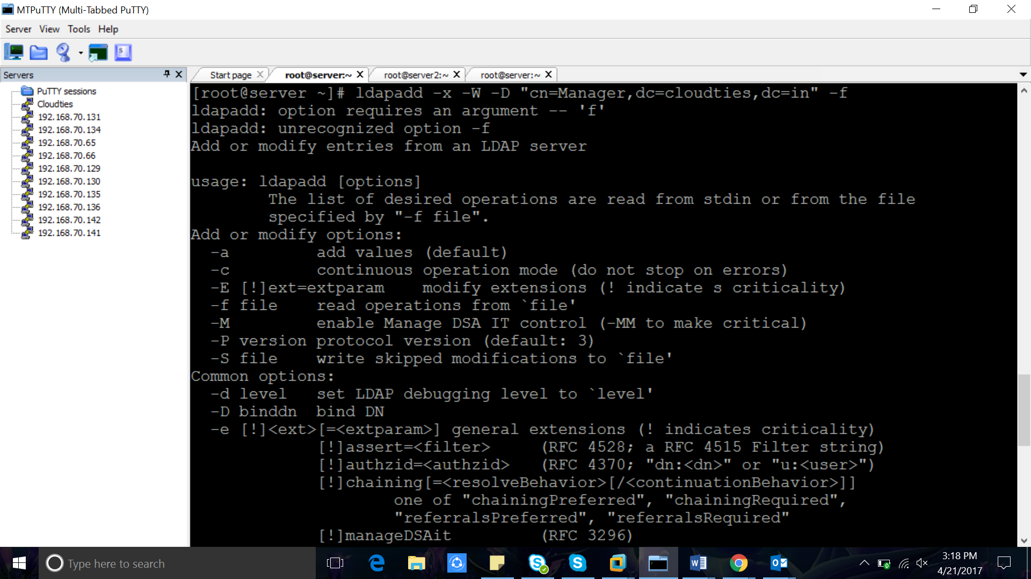  
============================================  
1. importing base.ldif  
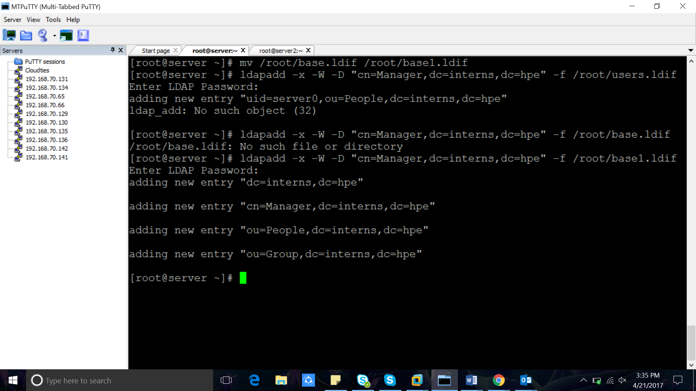  
[root@host4 migrationtools]# /root/base.ldif   
  
Enter LDAP Password:   
adding new entry "dc=cloudties,dc=in"  
  
adding new entry "cn=Manager,dc=cloudties,dc=in"  
  
adding new entry "ou=People,dc=cloudties,dc=in"  
  
adding new entry "ou=Group,dc=cloudties,dc=in"  
  
  
2. importing user.ldif  
  
[root@host4 migrationtools]# ldapadd -x -W -D "cn=Manager,dc=cloudties,dc=in" -f /root/users.ldif   
  
Enter LDAP Password:   
adding new entry "uid=test,ou=People,dc=cloudties,dc=in"  
  
adding new entry "uid=test1,ou=People,dc=cloudties,dc=in"  
  
adding new entry "uid=shafeeque,ou=People,dc=cloudties,dc=in"  
  
adding new entry "uid=shifin,ou=People,dc=cloudties,dc=in"  
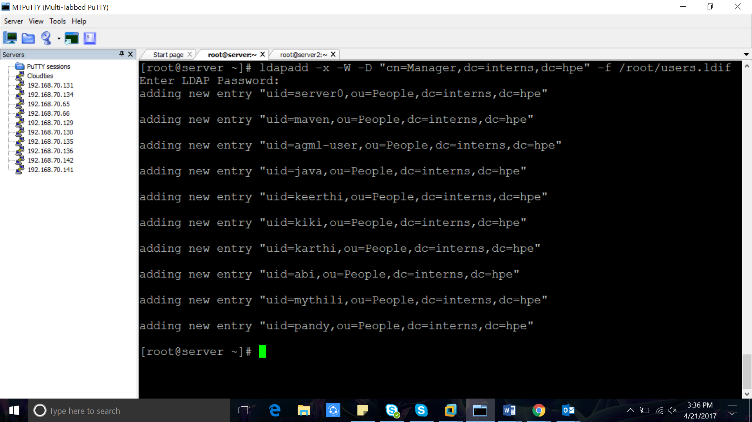  
  
3. importing group.ldif  
  
[root@host4 migrationtools]# ldapadd -x -W -D "cn=Manager,dc=cloudties,dc=in" -f /root/groups.ldif   
  
Enter LDAP Password:   
adding new entry "cn=test,ou=Group,dc=cloudties,dc=in"  
  
adding new entry "cn=test1,ou=Group,dc=cloudties,dc=in"  
  
adding new entry "cn=shafeeque,ou=Group,dc=cloudties,dc=in"  
  
adding new entry "cn=shifin,ou=Group,dc=cloudties,dc=in"  
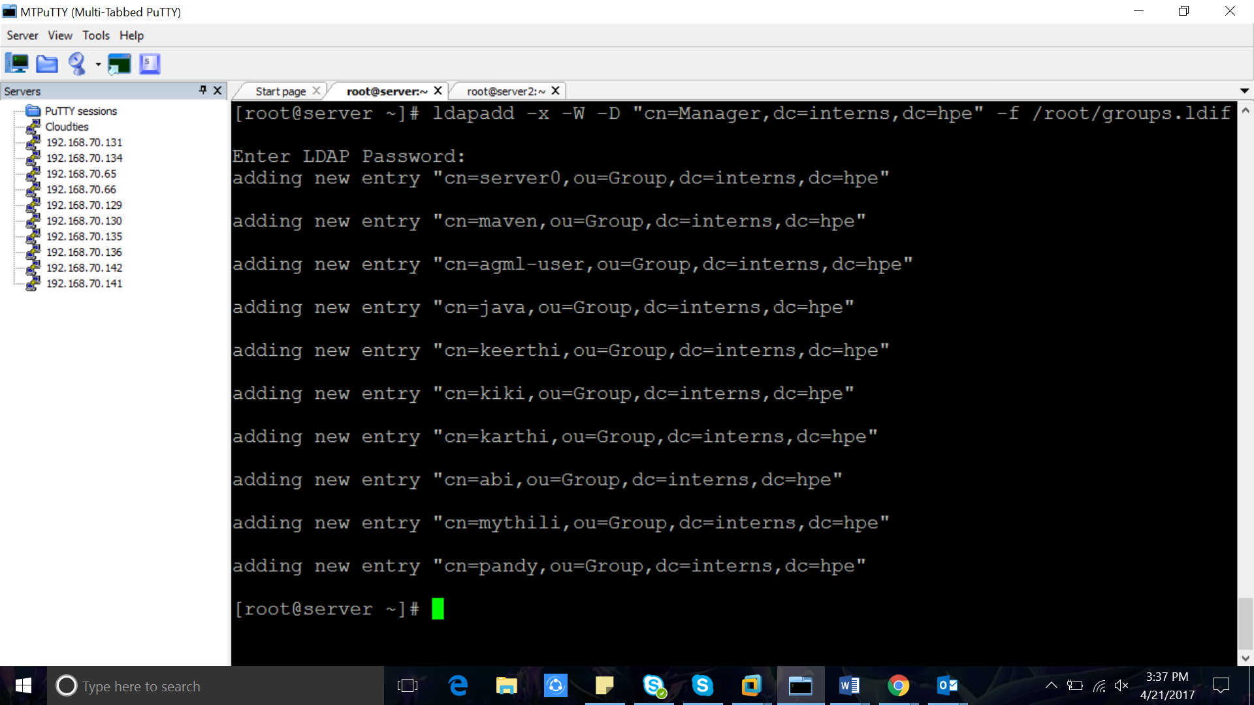  
==============================================================  
n7’[[[[[[[[[[[[  
12. Checking Whether users are imported correctly  
============================================================================  
[root@host4 migrationtools]# ldapsearch -x cn=shafeeque -b dc=cloudties,dc=in  
  
# extended LDIF  
#  
# LDAPv3  
# base <dc=cloudties,dc=in> with scope subtree  
# filter: cn=shafeeque  
# requesting: ALL  
#  
  
# shafeeque, People, cloudties.in  
dn: uid=shafeeque,ou=People,dc=cloudties,dc=in  
uid: shafeeque  
cn: shafeeque  
sn: shafeeque  
mail: shafeeque@cloudties.in  
objectClass: person  
objectClass: organizationalPerson  
objectClass: inetOrgPerson  
objectClass: posixAccount  
objectClass: top  
objectClass: shadowAccount  
userPassword:: e2NyeXB0fSQxJGxXMnhRbWFxJGFlNnFFdndJNWZWQWlVa2ZZOG9vdi8=  
shadowLastChange: 17275  
shadowMin: 0  
shadowMax: 99999  
shadowWarning: 7  
loginShell: /bin/bash  
uidNumber: 1002  
gidNumber: 1002  
homeDirectory: /home/shafeeque

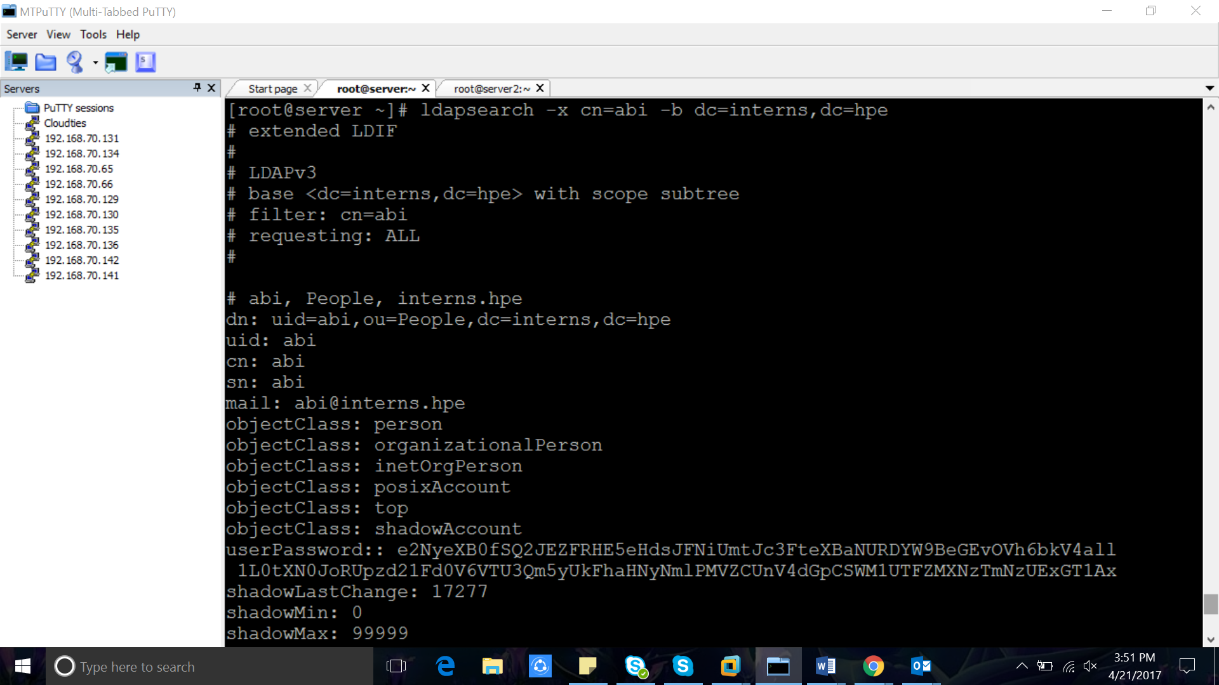

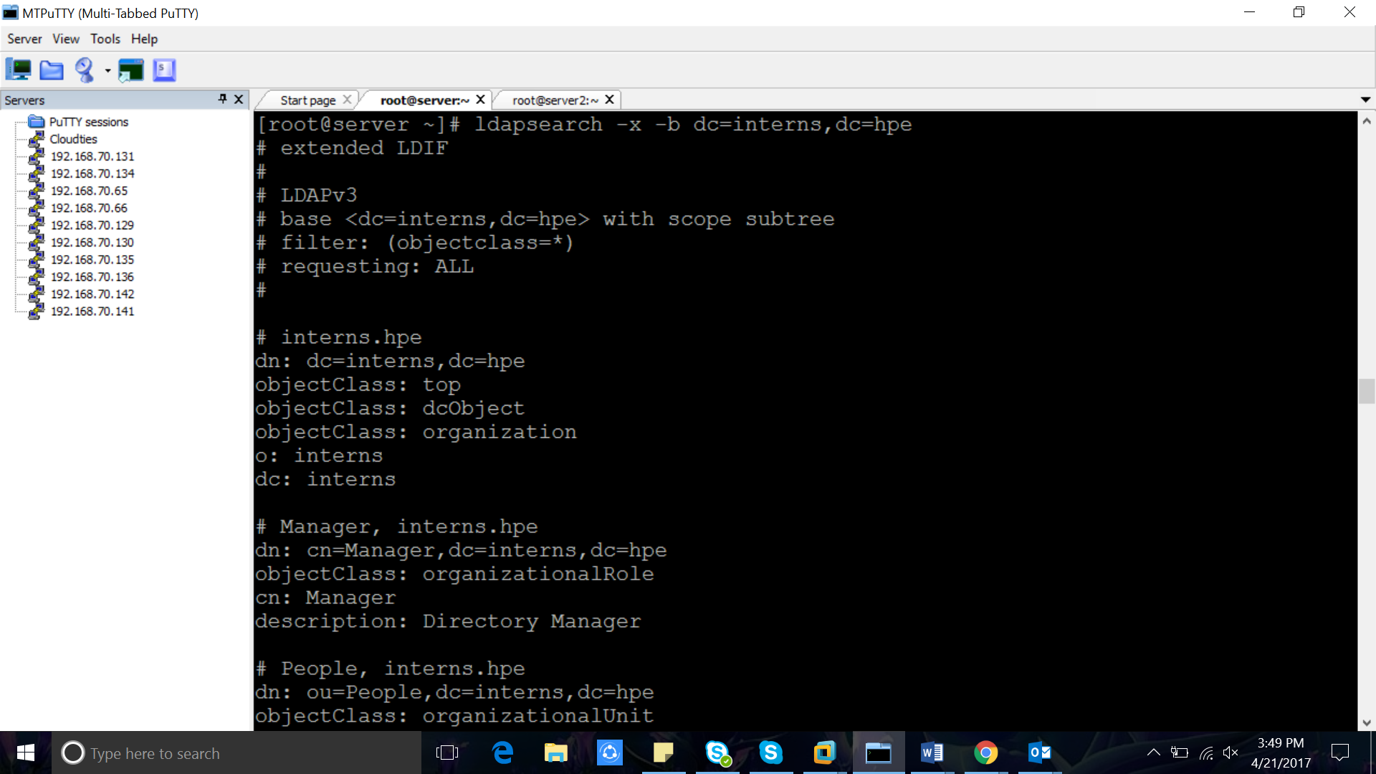

[root@server ~]# ldapsearch -x -b dc=interns,dc=hpe

# extended LDIF

#

# LDAPv3

# base <dc=interns,dc=hpe> with scope subtree

# filter: (objectclass=*)

# requesting: ALL

#

# interns.hpe

dn: dc=interns,dc=hpe

objectClass: top

objectClass: dcObject

objectClass: organization

o: interns

dc: interns

# Manager, interns.hpe

dn: cn=Manager,dc=interns,dc=hpe

objectClass: organizationalRole

cn: Manager

description: Directory Manager

# People, interns.hpe

dn: ou=People,dc=interns,dc=hpe

objectClass: organizationalUnit

ou: People

# Group, interns.hpe

dn: ou=Group,dc=interns,dc=hpe

objectClass: organizationalUnit

ou: Group

# server0, People, interns.hpe

dn: uid=server0,ou=People,dc=interns,dc=hpe

uid: server0

cn: server0

sn: server0

mail: server0@interns.hpe

objectClass: person

objectClass: organizationalPerson

objectClass: inetOrgPerson

objectClass: posixAccount

objectClass: top

objectClass: shadowAccount

userPassword:: e2NyeXB0fSQxJHYxZmxuMjE4JHlCMU4xWTlZMG0vRTNoQW8ubDhYOC8=

shadowLastChange: 17235

shadowMin: 0

shadowMax: 99999

shadowWarning: 7

loginShell: /bin/bash

uidNumber: 1000

gidNumber: 1000

homeDirectory: /home/server0

gecos: server0

# maven, People, interns.hpe

dn: uid=maven,ou=People,dc=interns,dc=hpe

uid: maven

cn: maven

sn: maven

mail: maven@interns.hpe

objectClass: person

objectClass: organizationalPerson

objectClass: inetOrgPerson

objectClass: posixAccount

objectClass: top

objectClass: shadowAccount

userPassword:: e2NyeXB0fSQxJFd0VkZHd1Y4JE1ETWkubUNIRzl1VElhSWR2aFV0VjA=

shadowLastChange: 17235

shadowMin: 0

shadowMax: 99999

shadowWarning: 7

loginShell: /bin/bash

uidNumber: 1001

gidNumber: 1001

homeDirectory: /home/maven

# agml-user, People, interns.hpe

dn: uid=agml-user,ou=People,dc=interns,dc=hpe

uid: agml-user

cn: agml-user

sn: agml-user

mail: agml-user@interns.hpe

objectClass: person

objectClass: organizationalPerson

objectClass: inetOrgPerson

objectClass: posixAccount

objectClass: top

objectClass: shadowAccount

userPassword:: e2NyeXB0fSEh

shadowLastChange: 17238

shadowMin: 0

shadowMax: 99999

shadowWarning: 7

loginShell: /bin/bash

uidNumber: 1002

gidNumber: 1002

homeDirectory: /home/agml-user

# java, People, interns.hpe

dn: uid=java,ou=People,dc=interns,dc=hpe

uid: java

cn: java

sn: java

mail: java@interns.hpe

objectClass: person

objectClass: organizationalPerson

objectClass: inetOrgPerson

objectClass: posixAccount

objectClass: top

objectClass: shadowAccount

userPassword:: e2NyeXB0fSQxJEhBQThNRExtJHBZSDZPb3QvaEJndzJWRWlHaGhGUy8=

shadowLastChange: 17259

shadowMin: 0

shadowMax: 99999

shadowWarning: 7

loginShell: /bin/bash

uidNumber: 1003

gidNumber: 1003

homeDirectory: /home/java

# keerthi, People, interns.hpe

dn: uid=keerthi,ou=People,dc=interns,dc=hpe

uid: keerthi

cn: keerthi

sn: keerthi

mail: keerthi@interns.hpe

objectClass: person

objectClass: organizationalPerson

objectClass: inetOrgPerson

objectClass: posixAccount

objectClass: top

objectClass: shadowAccount

userPassword:: e2NyeXB0fSQxJHdySWdpZ3gyJC5Jekw0Q0hWRnluS3BteWxPLjRWaS8=

shadowLastChange: 17262

shadowMin: 0

shadowMax: 99999

shadowWarning: 7

loginShell: /bin/bash

uidNumber: 1004

gidNumber: 1004

homeDirectory: /home/keerthi

# kiki, People, interns.hpe

dn: uid=kiki,ou=People,dc=interns,dc=hpe

uid: kiki

cn: kiki

sn: kiki

mail: kiki@interns.hpe

objectClass: person

objectClass: organizationalPerson

objectClass: inetOrgPerson

objectClass: posixAccount

objectClass: top

objectClass: shadowAccount

userPassword:: e2NyeXB0fSQ2JEJrVkU3T096JFFmSUV2bmVpYTZYUmxCYnRJNTR2V2Q3TzZoMGF

vZGNUUjR6RXI0RnRHNFZDenJTZGMyWW1xR0NuM2lxRUVlY0ZQcDFnUUJtLnZaOUFwRzBtNlByQlMw

shadowLastChange: 17262

shadowMin: 0

shadowMax: 99999

shadowWarning: 7

loginShell: /bin/bash

uidNumber: 1005

gidNumber: 1005

homeDirectory: /home/kiki

# karthi, People, interns.hpe

dn: uid=karthi,ou=People,dc=interns,dc=hpe

uid: karthi

cn: karthi

sn: karthi

mail: karthi@interns.hpe

objectClass: person

objectClass: organizationalPerson

objectClass: inetOrgPerson

objectClass: posixAccount

objectClass: top

objectClass: shadowAccount

userPassword:: e2NyeXB0fSQ2JGtzeTBwc1FLJGhvdGpxMU54R3JpU0ZNWDg4aHhCZC5tdkE4OXF

ITTFIWGwvNmlSbnFsamVJSE9UTnF3U0lVY3k3b1FvUVpNbjBkcW1xRUZSSHR1bk5tcEc3SENsNlgv

shadowLastChange: 17277

shadowMin: 0

shadowMax: 99999

shadowWarning: 7

loginShell: /bin/bash

uidNumber: 1006

gidNumber: 1006

homeDirectory: /home/karthi

# abi, People, interns.hpe

dn: uid=abi,ou=People,dc=interns,dc=hpe

uid: abi

cn: abi

sn: abi

mail: abi@interns.hpe

objectClass: person

objectClass: organizationalPerson

objectClass: inetOrgPerson

objectClass: posixAccount

objectClass: top

objectClass: shadowAccount

userPassword:: e2NyeXB0fSQ2JEZFRHE5eHdsJFNiUmtJc3FteXBaNURDYW9BeGEvOVh6bkV4all

1L0tXN0JoRUpzd21Fd0V6VTU3Qm5yUkFhaHNyNmlPMVZCUnV4dGpCSWM1UTFZMXNzTmNzUExGT1Ax

shadowLastChange: 17277

shadowMin: 0

shadowMax: 99999

shadowWarning: 7

loginShell: /bin/bash

uidNumber: 1007

gidNumber: 1007

homeDirectory: /home/abi

# mythili, People, interns.hpe

dn: uid=mythili,ou=People,dc=interns,dc=hpe

uid: mythili

cn: mythili

sn: mythili

mail: mythili@interns.hpe

objectClass: person

objectClass: organizationalPerson

objectClass: inetOrgPerson

objectClass: posixAccount

objectClass: top

objectClass: shadowAccount

userPassword:: e2NyeXB0fSQ2JDVQaDlCaWE0JHAucFZZdmVYeEVhWmV1dFVBWVJjTUVnVS4zS0t

mMWMwdDNJWEkxV0NBejZFRDhRa1dRVkpuaEM3Sm1zOHBTR0ZtdENhSGYvSzAzMGRrSDRaNkFNQXYu

shadowLastChange: 17277

shadowMin: 0

shadowMax: 99999

shadowWarning: 7

loginShell: /bin/bash

uidNumber: 1008

gidNumber: 1008

homeDirectory: /home/mythili

# pandy, People, interns.hpe

dn: uid=pandy,ou=People,dc=interns,dc=hpe

uid: pandy

cn: pandy

sn: pandy

mail: pandy@interns.hpe

objectClass: person

objectClass: organizationalPerson

objectClass: inetOrgPerson

objectClass: posixAccount

objectClass: top

objectClass: shadowAccount

userPassword:: e2NyeXB0fSQ2JFU1Lzg3SGI3JGN4bnNvY2FoTy5mVlB3RWxRTHJZdlFiUmFPUDF

La0RzS1ZaTjdiOFk4MnN6TUFqdUpYSExNWThlQVhIcGJPL3pCSkNwQUc3R2QuN1JyQnJ1SkN1cUww

shadowLastChange: 17277

shadowMin: 0

shadowMax: 99999

shadowWarning: 7

loginShell: /bin/bash

uidNumber: 1009

gidNumber: 1009

homeDirectory: /home/pandy

# server0, Group, interns.hpe

dn: cn=server0,ou=Group,dc=interns,dc=hpe

objectClass: posixGroup

objectClass: top

cn: server0

userPassword:: e2NyeXB0fXg=

gidNumber: 1000

memberUid: 1000

# maven, Group, interns.hpe

dn: cn=maven,ou=Group,dc=interns,dc=hpe

objectClass: posixGroup

objectClass: top

cn: maven

userPassword:: e2NyeXB0fXg=

gidNumber: 1001

memberUid: 1001

# agml-user, Group, interns.hpe

dn: cn=agml-user,ou=Group,dc=interns,dc=hpe

objectClass: posixGroup

objectClass: top

cn: agml-user

userPassword:: e2NyeXB0fXg=

gidNumber: 1002

memberUid: 1002

# java, Group, interns.hpe

dn: cn=java,ou=Group,dc=interns,dc=hpe

objectClass: posixGroup

objectClass: top

cn: java

userPassword:: e2NyeXB0fXg=

gidNumber: 1003

memberUid: 1003

# keerthi, Group, interns.hpe

dn: cn=keerthi,ou=Group,dc=interns,dc=hpe

objectClass: posixGroup

objectClass: top

cn: keerthi

userPassword:: e2NyeXB0fXg=

gidNumber: 1004

memberUid: 1004

# kiki, Group, interns.hpe

dn: cn=kiki,ou=Group,dc=interns,dc=hpe

objectClass: posixGroup

objectClass: top

cn: kiki

userPassword:: e2NyeXB0fXg=

gidNumber: 1005

memberUid: 1005

# karthi, Group, interns.hpe

dn: cn=karthi,ou=Group,dc=interns,dc=hpe

objectClass: posixGroup

objectClass: top

cn: karthi

userPassword:: e2NyeXB0fXg=

gidNumber: 1006

memberUid: 1006

# abi, Group, interns.hpe

dn: cn=abi,ou=Group,dc=interns,dc=hpe

objectClass: posixGroup

objectClass: top

cn: abi

userPassword:: e2NyeXB0fXg=

gidNumber: 1007

memberUid: 1007

# mythili, Group, interns.hpe

dn: cn=mythili,ou=Group,dc=interns,dc=hpe

objectClass: posixGroup

objectClass: top

cn: mythili

userPassword:: e2NyeXB0fXg=

gidNumber: 1008

memberUid: 1008

# pandy, Group, interns.hpe

dn: cn=pandy,ou=Group,dc=interns,dc=hpe

objectClass: posixGroup

objectClass: top

cn: pandy

userPassword:: e2NyeXB0fXg=

gidNumber: 1009

memberUid: 1009

# search result

search: 2

result: 0 Success

# numResponses: 25

# numEntries: 24  
==================================================================  
  
Integrating Clients to LDAP Server  
===========================  
  
1. Installing Packages  
  
yum install openldap-clients nss-pam-ldapd -y  
  
2.Enter the command authconfig-tui  
  
[root@host3 ~]# authconfig-tui  
  
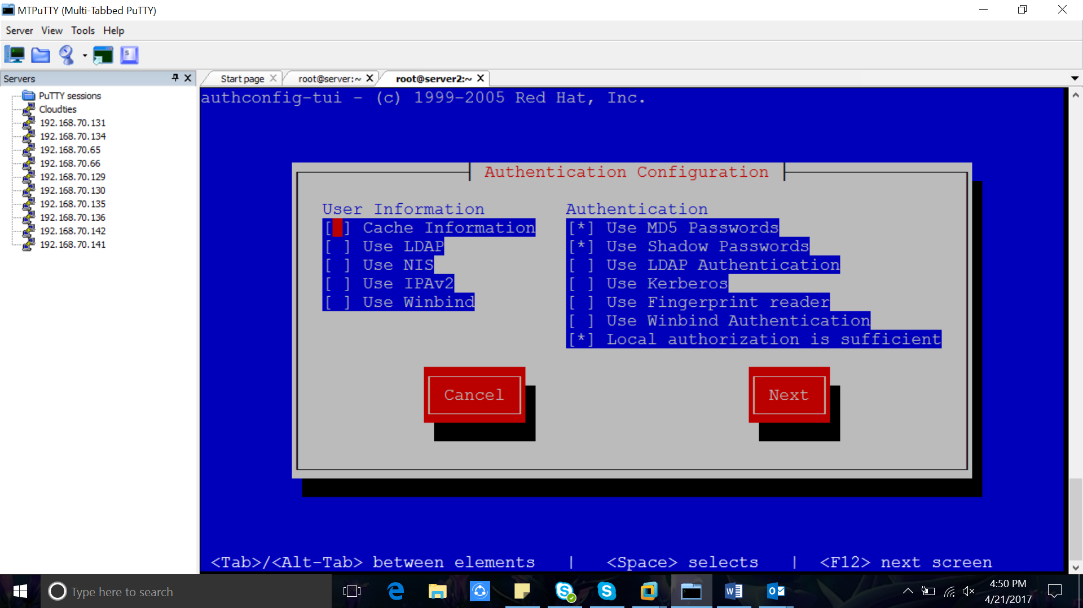

Press space to make star mark

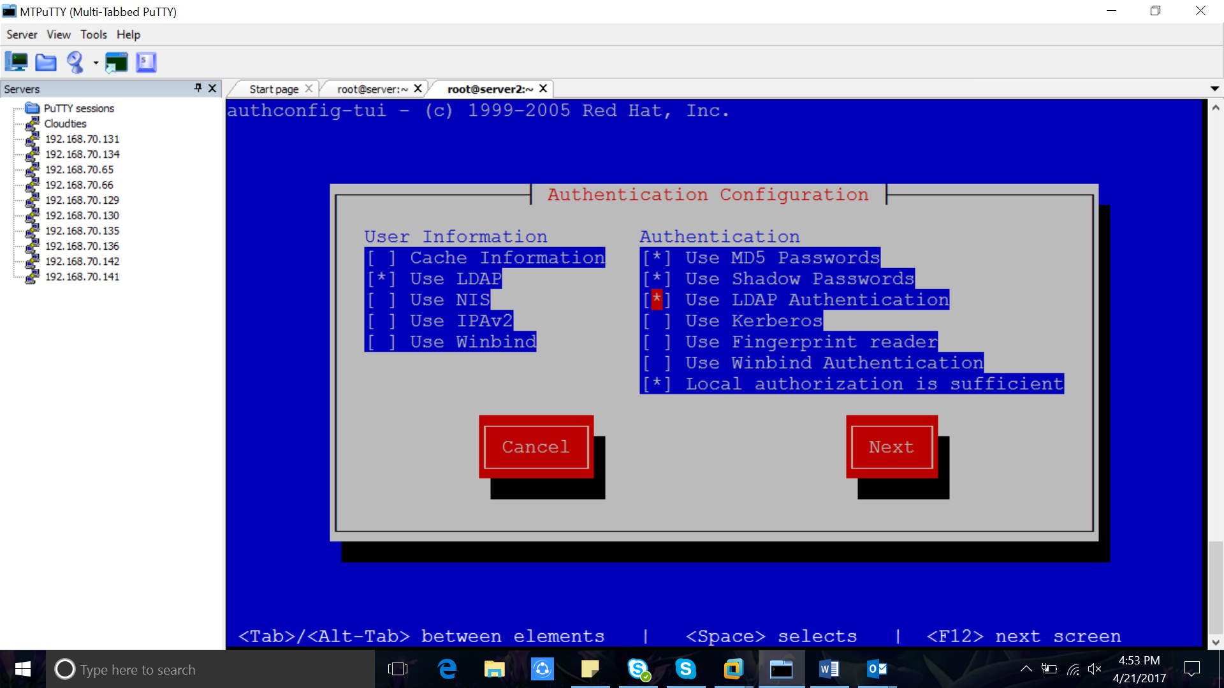  
2.1 Under User Information => mark Use LDAP  
Under Authentication => mark Use LDAP Authentication   
  
Enter Next  
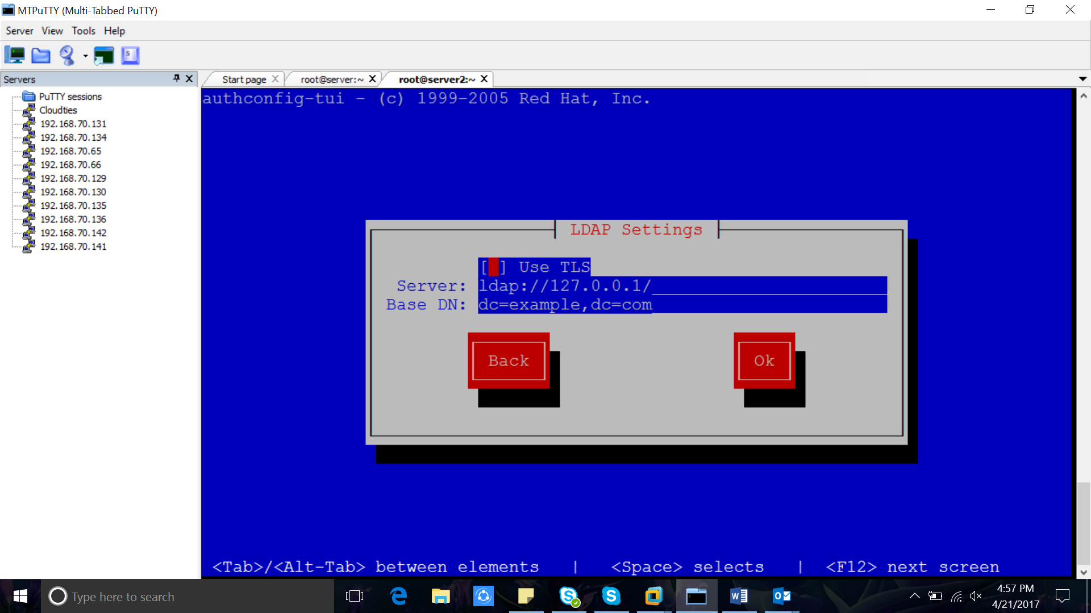  
2.2 In LDAP Settings give LDAP Server Details  
  
Server: ldap://172.16.234.136  
Base DN: dc=cloudties,dc=in 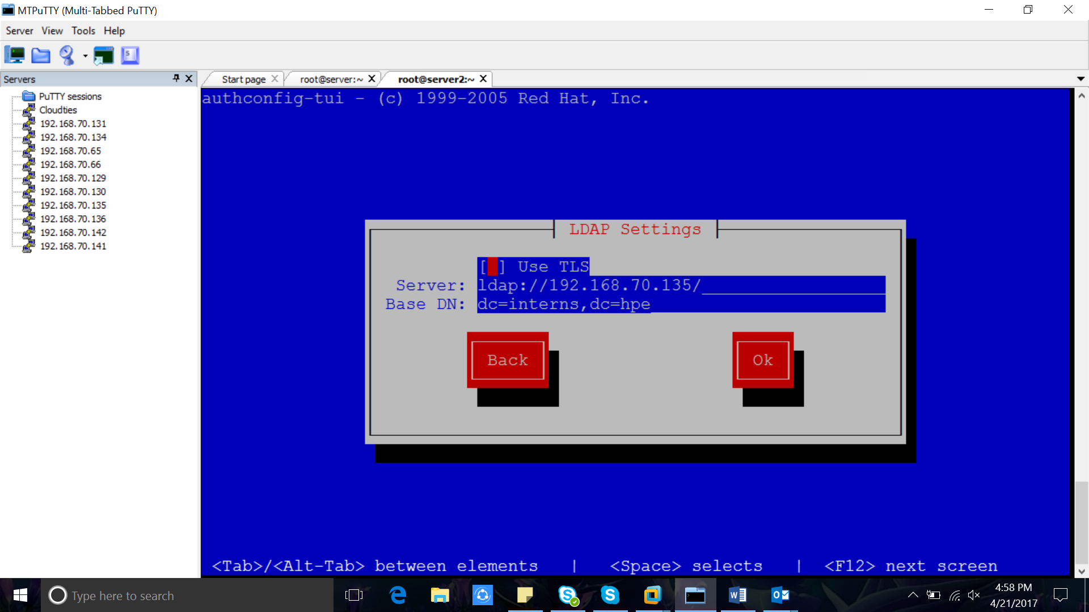  
  
Enter Next  
  
  
3. Check user details from LDAP server  
  
[root@host3 ~]# getent passwd shifin  
shifin:x:1003:1003:shifin:/home/shifin:/bin/bash  
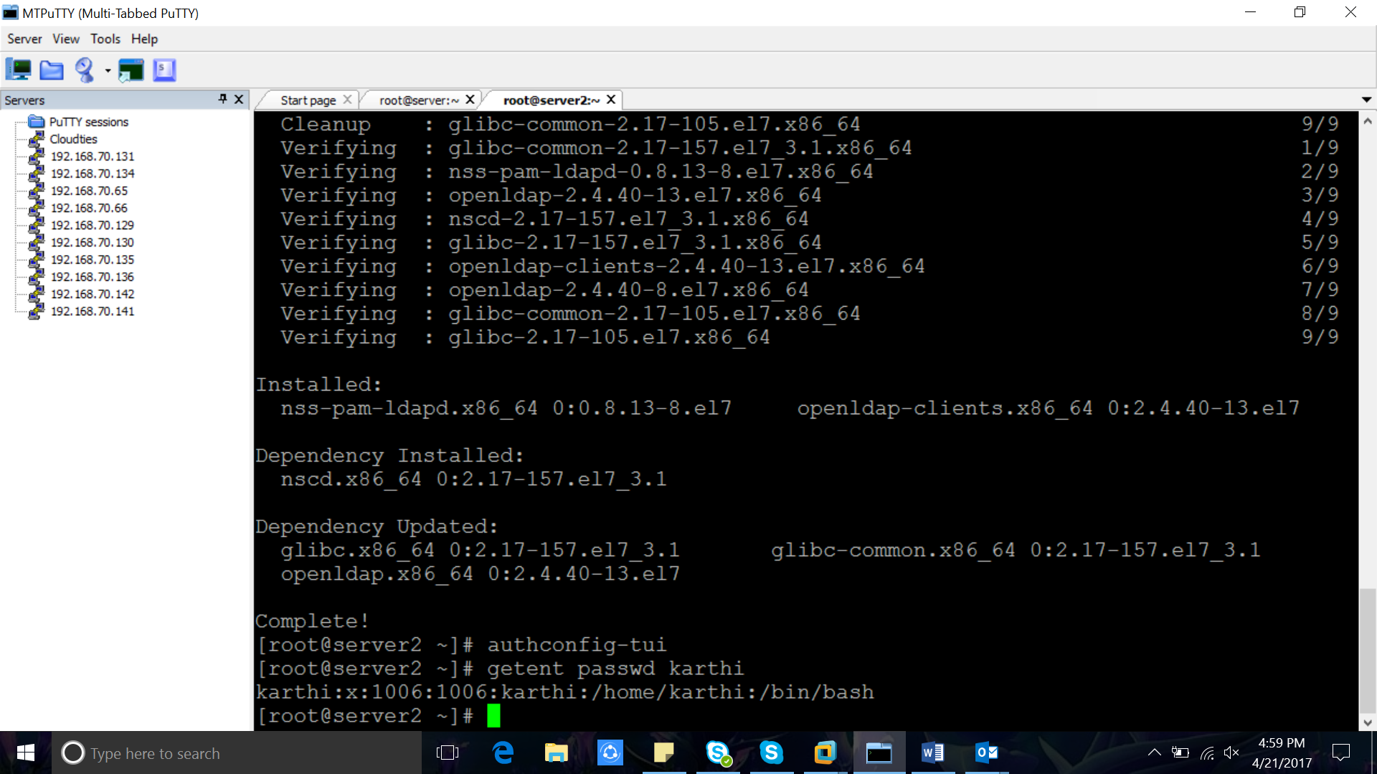  
if you are getting the output , client is connecting to LDAP Server  
  
Exporting the Home directory of LDAP users  
==========================================  
  
In the Server  
----------------------  
  
Create Nfs share for home directory  
  
vi /etc/exports  
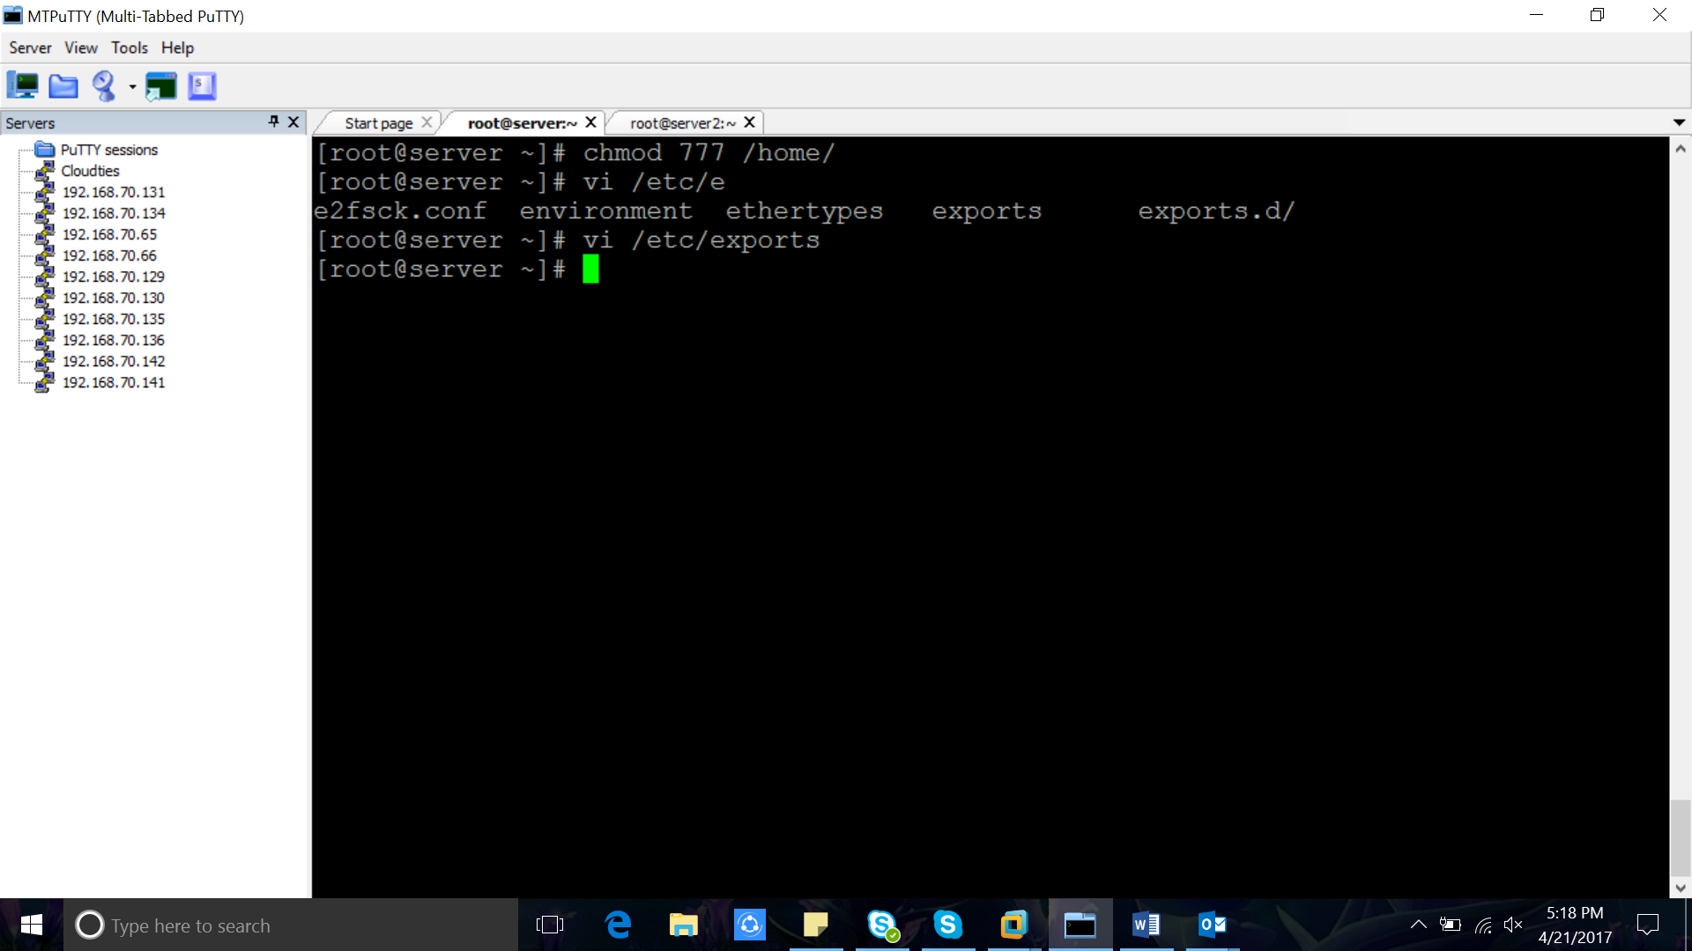  
/home/ * (rw)  
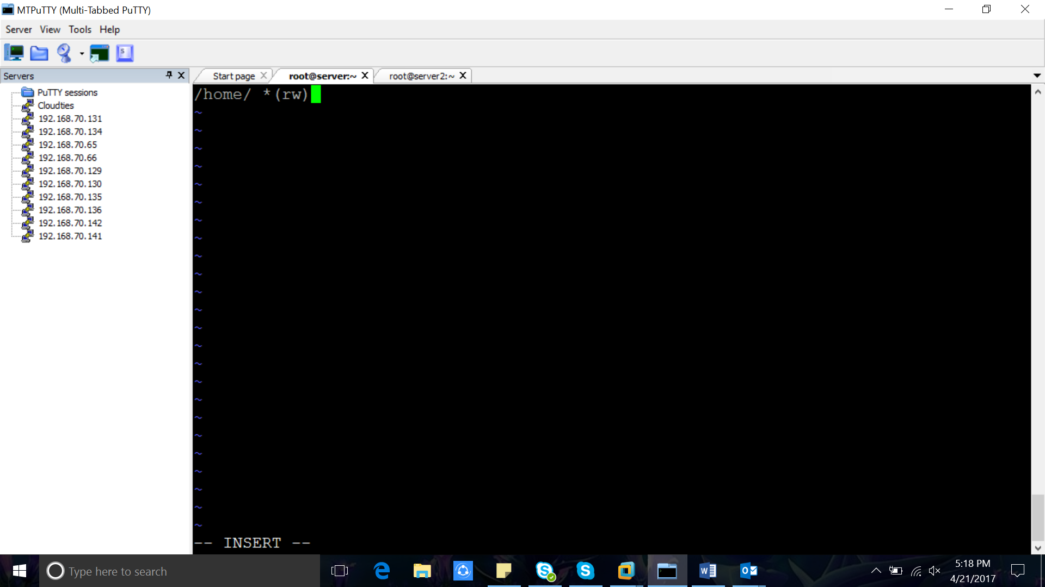  
save and exit the file  
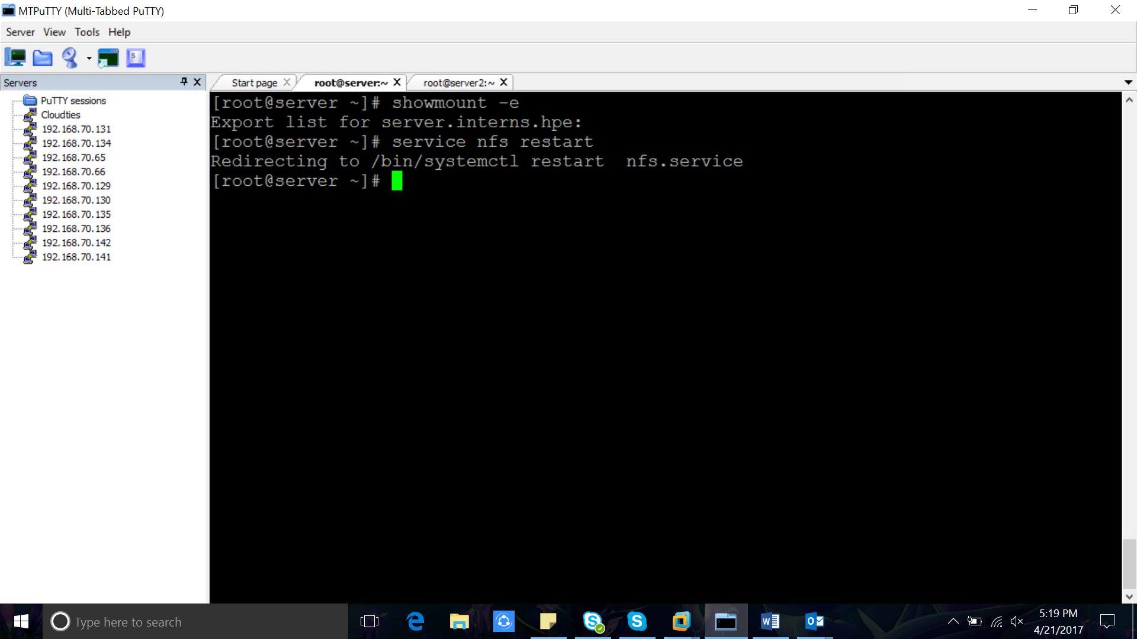  
Install Nfs packages if it is not already installed   
  
yum -y install rpcbind nfs-utils  
  
Start the NFS services  
  
1. systemctl start rpcbind  
2. systemctl start nfs  
  
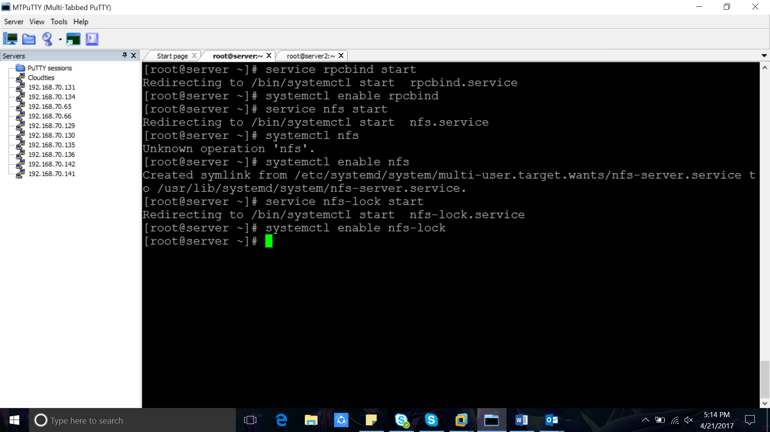  
  
In client:

Yum install nfs-utils -y

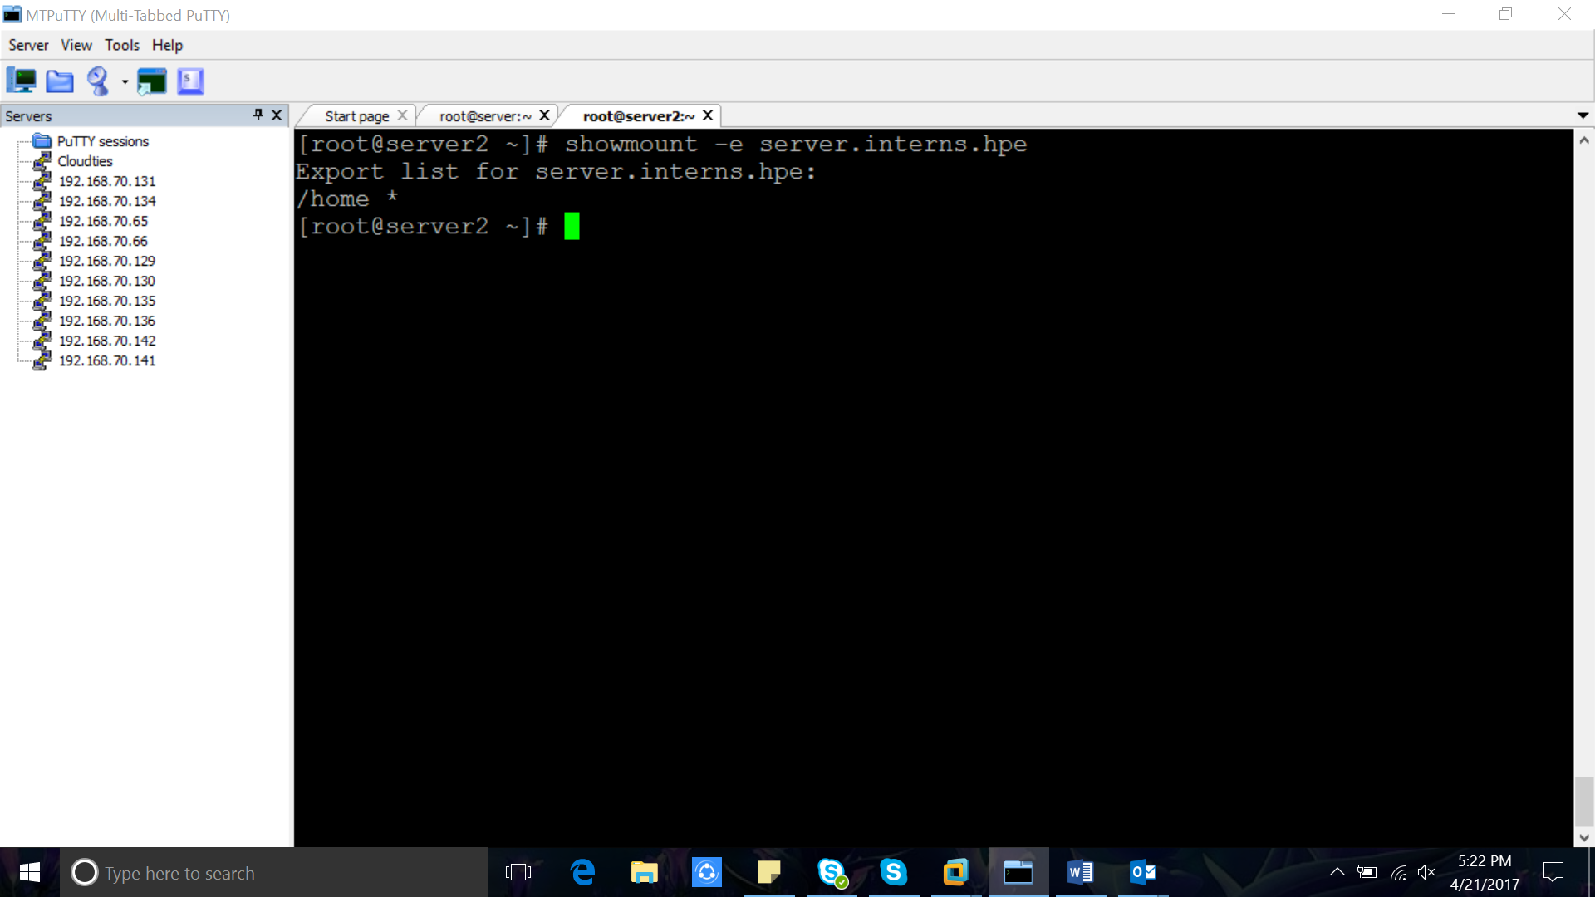  
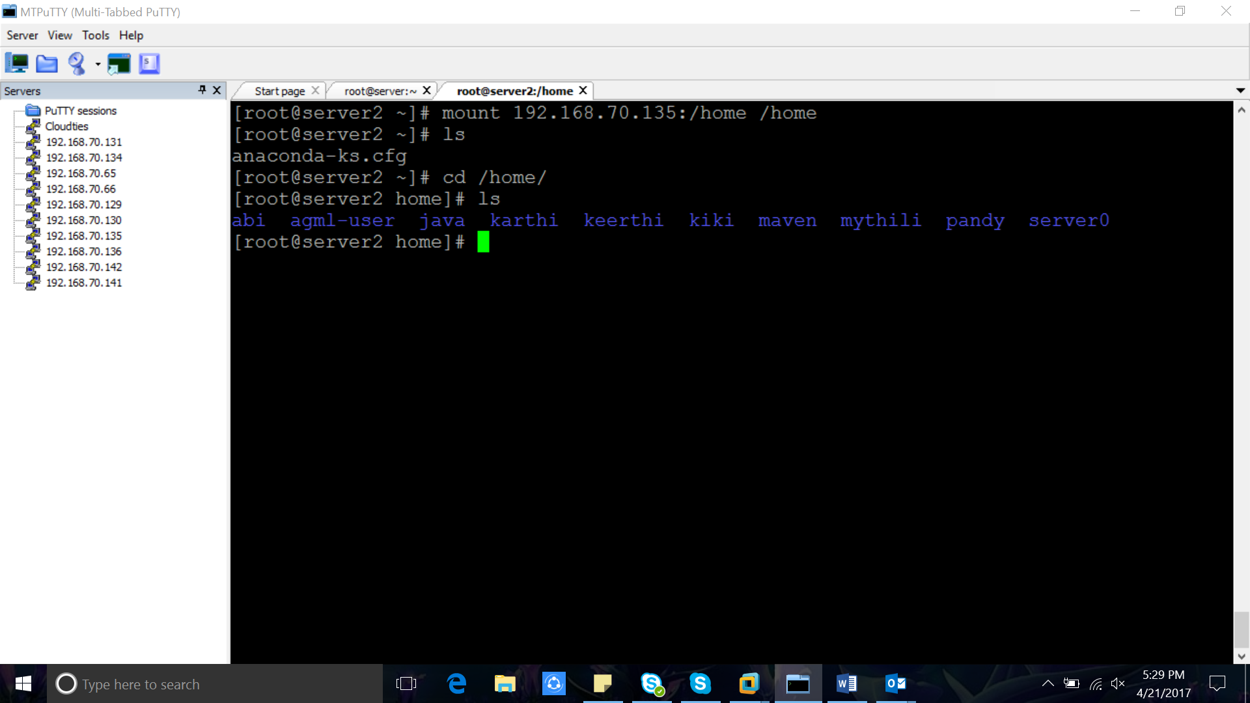

Umount –l /home/ or umount –f /home/ -> to forcefully stop mounting.

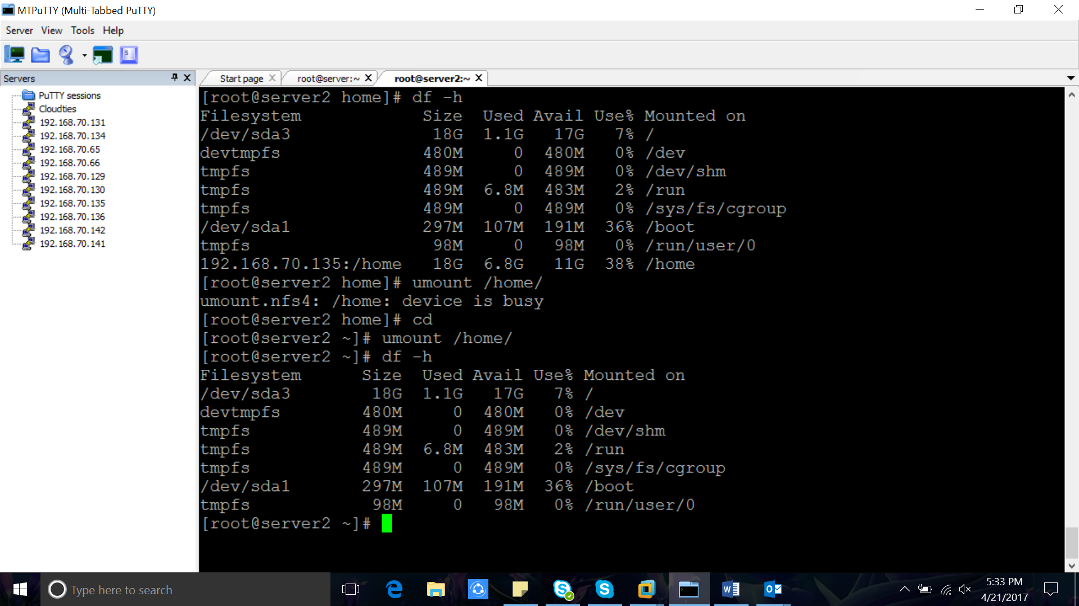  
  
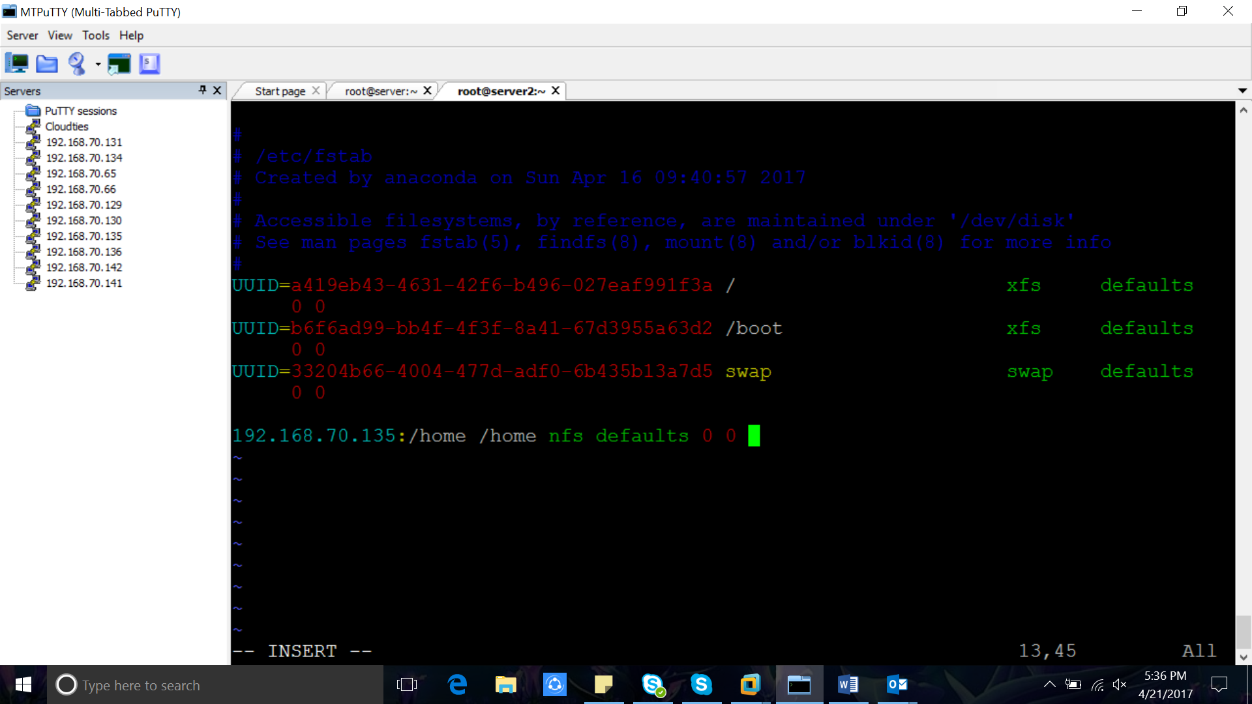 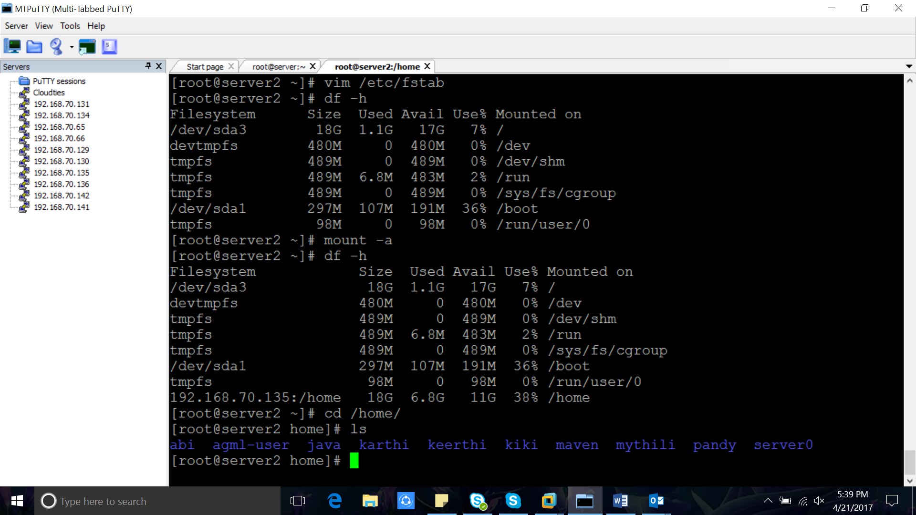

Automatic mounting:

# autofs

Whenever there is need we can mount.

#yum install autofs -y  
#vim /etc/auto.master

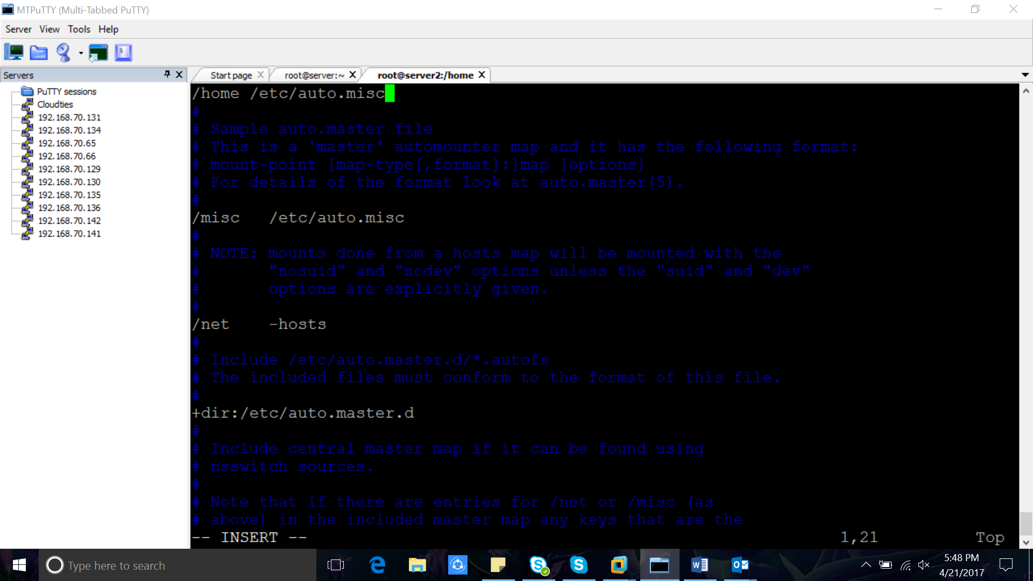

#vim /etc/auto.misc

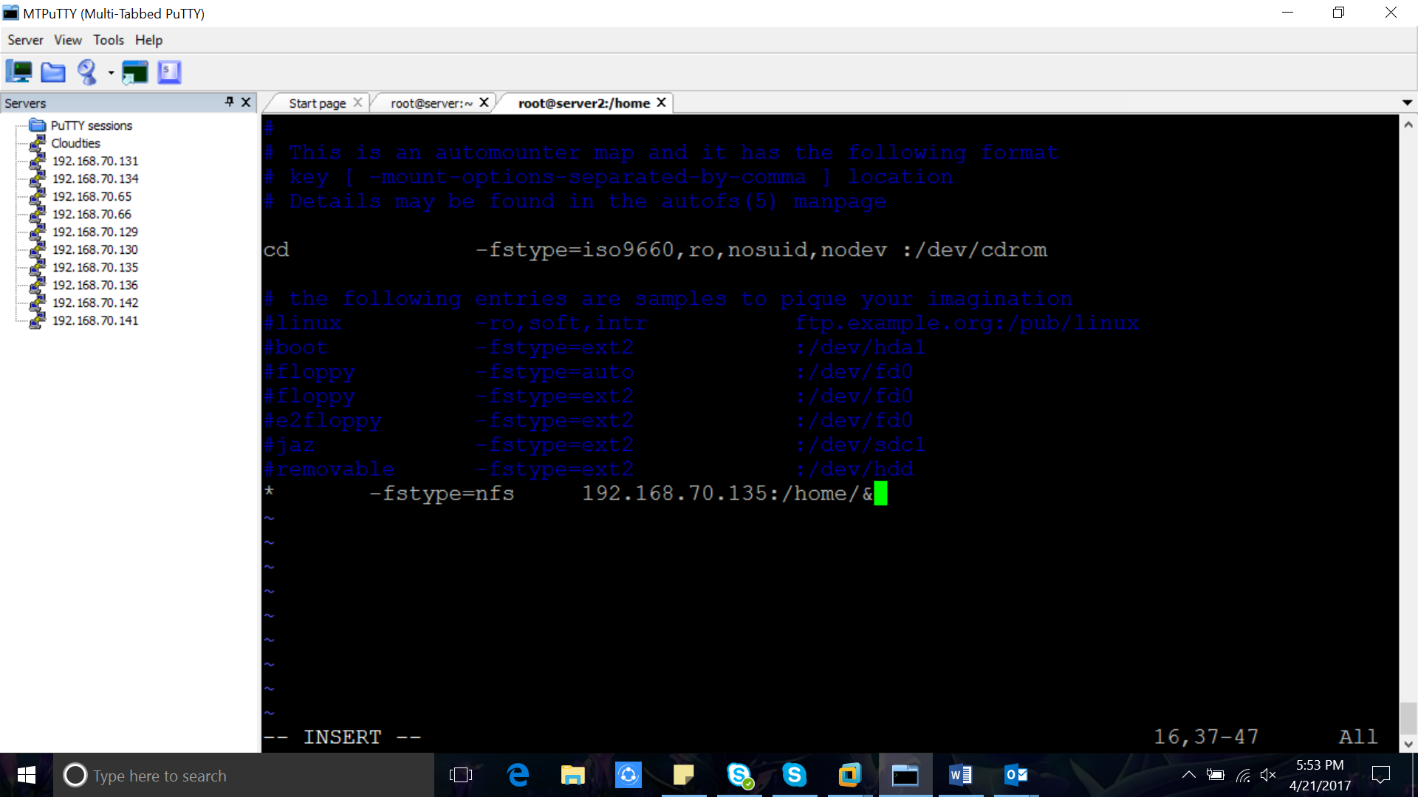

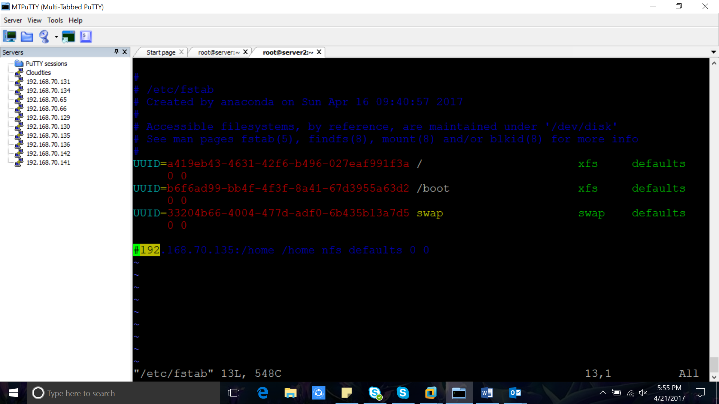 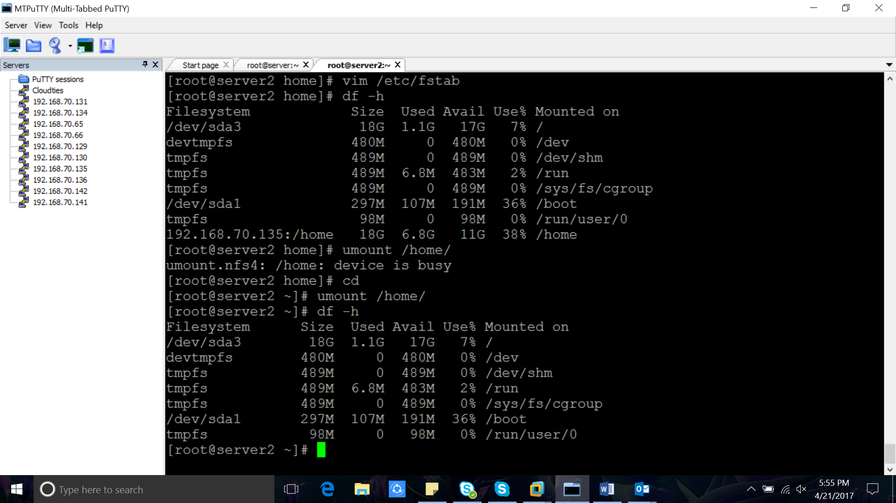  
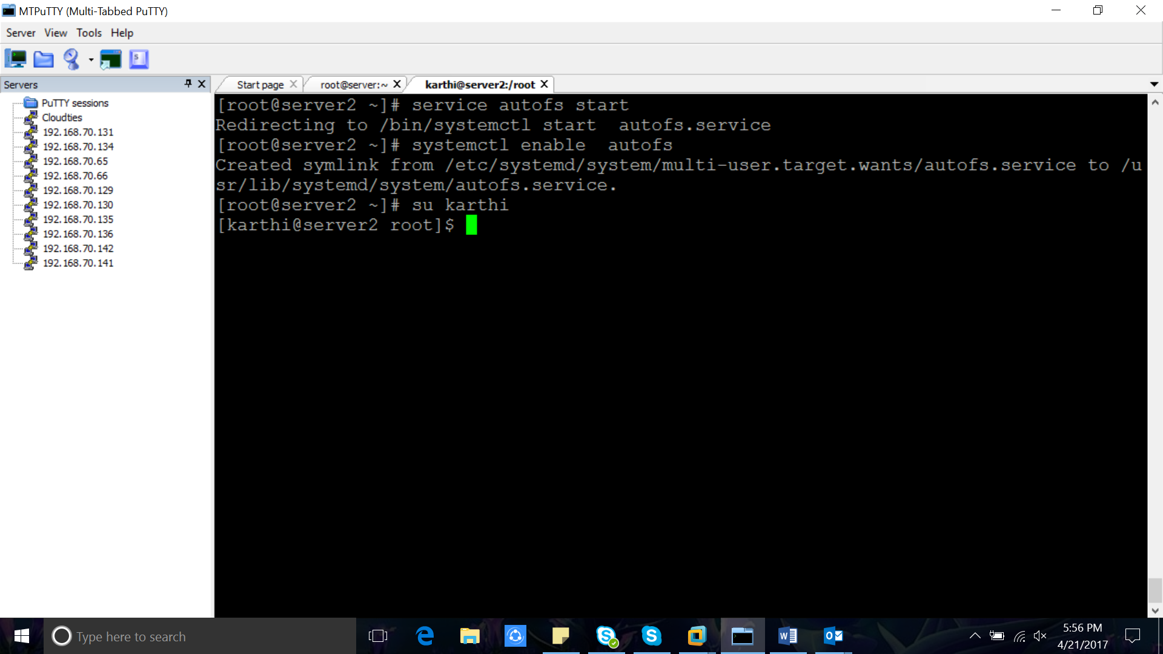 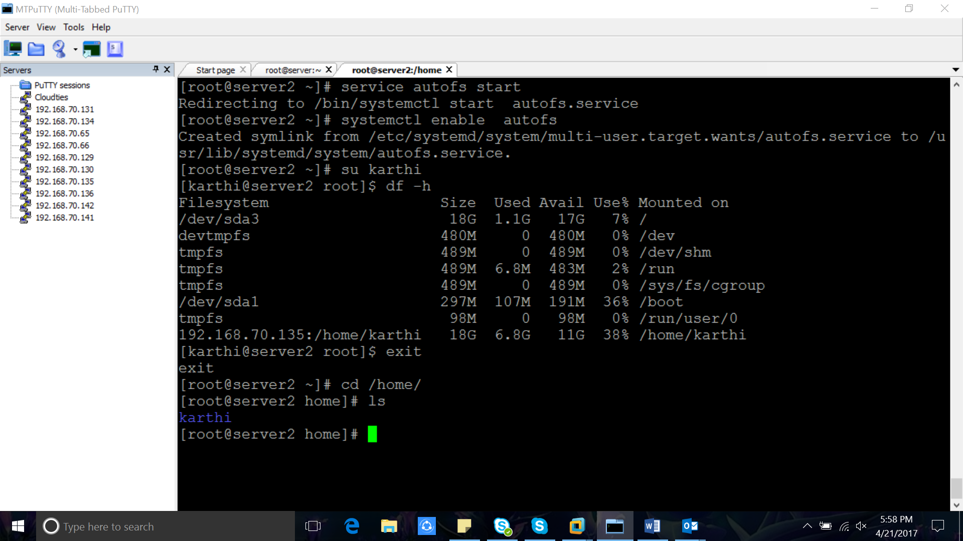 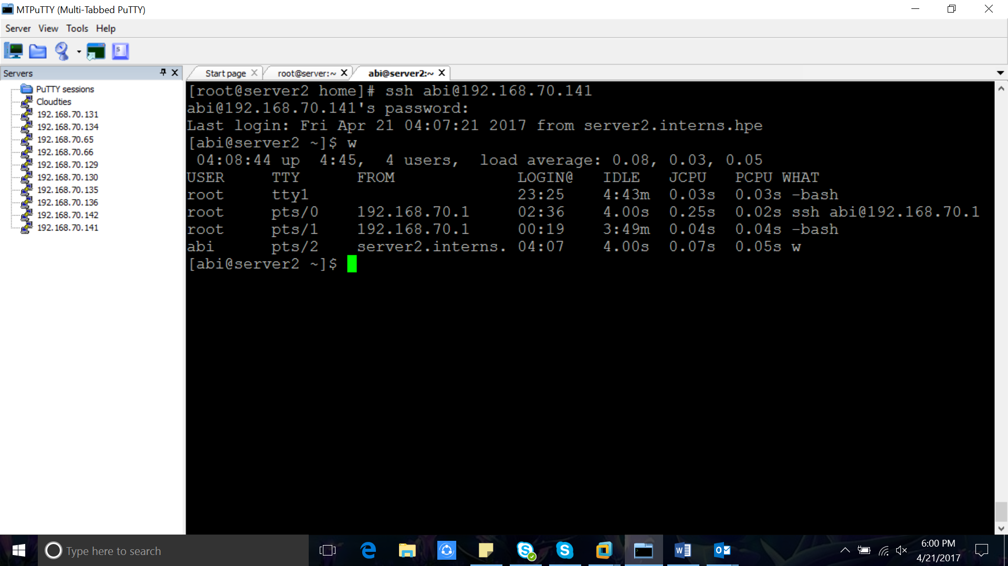 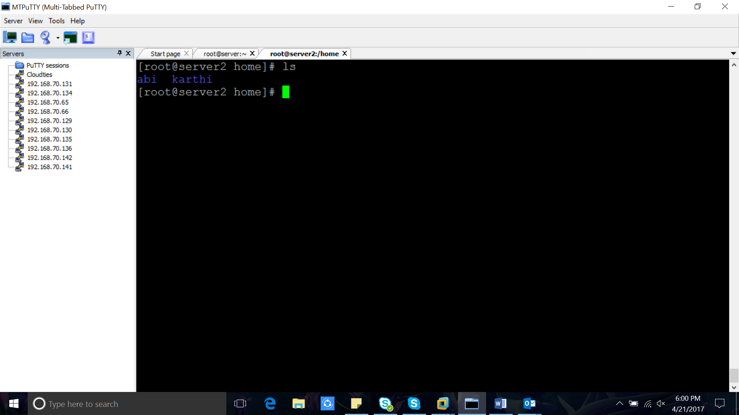

# vim /etc/autofs.conf 